2025
VETO SPORTS
SCHOOL FUTSAL LEAGUE



Information

Table of Contents

Competition details | ……………………………………….. | 3
Format, Age Groups, Finals, Nominations, Draws
Conference Dates
Central Conference | ………………………………………… | 5
Western Conference | ……………………………………….. | 6
Northern Conference | ……………………………………….. | 7
Southern Conference | ……………………………………….. | 8
Match Rules | ……………………………………….. | 9
Costs/ Referees | ……………………………………….. | 12
Documents / website | ……………………………………….. | 14
Team Lists | ……………………………………….. | 15
Squad Lists | ………………………………………. | 16
Communication | ………………………………………. | 17
Staff | ………………………………………. | 18
Social media | ………………………………………. | 19
Sponsors | ………………………………………. | 23
2025 QSF Calendar | ………………………………………. | 25
Competition Details

FORMAT
The VETO SPORTS 2025 School Futsal League will be divided into 4 Conferences – Central, Western, Northern & Southern. Each conference will be comprised of 10 Boys teams and 10 Girls teams and will play “9 matches/rounds” over 3 Gala Days (3 Rounds per Gala Day). There will be one Gala Day per term with Finals in Term 4.

AGE GROUPS: Boys and Girls
12 Years (Students cannot turn 13 or older in 2025)
14 Years (Students cannot turn 15 or older in 2025)
16 Years (Students cannot turn 17 or older in 2025)
Opens (The open competition will play in Semester 1 only)

FINALS:
The teams finishing first in each conference after the 9 rounds will be crowned “Conference Premiers”.
The top 3 teams in each conference will play in the SFL Champions Final Day to decide the 2025 VETO Sports SFL Champions. Teams finishing 4th, 5th & 6th in each conference will play for the VETO Sports SFL Shield.

NOMINATIONS
Nomination forms are available on the QSF website and will close at the end of Week 10, Term 4, 2024.
All conferences will have maximum of 10 Boys and 10 Girls teams, so schools nominating after the competition limits have been filled, will be placed on "Reserve" lists.
Competition Invoices will be sent in Week 1, Term 1, 2025 and nominations will then be finalised after nomination fees have been paid.

DRAWS
The Draws for all 4 Conferences will be made after nominations have been finalised, and available in Week 1, Term 1, 2025 on the QSF Website.
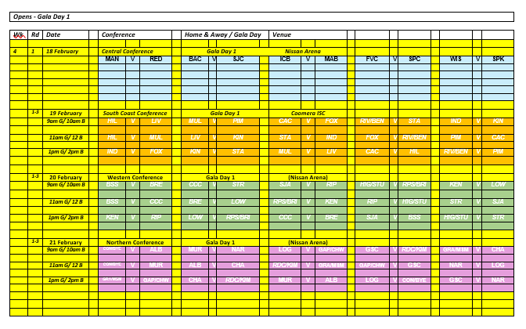
Central Conference Details
VENUE: Nissan Arena Indoor Sports Centre – Mains Rd Macgregor

FORMAT:
The Central Conference will be a 10 - team conference that will play 3 Gala Days with each Gala Day being comprised of 3 rounds over 3 terms. Boys and girl’s rounds will be played together each week. Teams finishing 1st, 2nd or 3rd in each conference will qualify for Champions Final Day. Teams finishing 4th, 5th or 6th in each conference qualify for Shield FD.
DATES:
14 Years – | Gala Day 1 | Tuesday | 11th February
 | Gala Day 2 | Tuesday | 13th May
 | Gala Day 3 | Monday | 4th August
 | Shield Final Day | Thursday | 15th October
 | Champions FD | Friday | 16th October
Opens - | Gala Day 1 | Tuesday | 11th February
 | Gala Day 2 | Friday | 21st March
 | Gala Day 3 | Tuesday | 13th May
 | Shield Final Day | Tuesday | 10th June
 | Champions FD | Wednesday | 11th June
12 Years - | Gala Day 1 (tbc) | Tuesday | 18th February
 | Gala Day 2 (tbc) | Tuesday | 20th May
 | Gala Day 3 (tbc) | Tuesday | 19th August
 | Shield Final Day | Tuesday | 13th October
 | Champions FD | Wednesday | 14th October
16 Years | Gala Day 1 | Tuesday | 18th February
 | Gala Day 2 | Tuesday | 20th May
 | Gala Day 3 | Tuesday | 19th August
 | Shield Final Day | Tuesday | 13th October
 | Champions FD | Wednesday | 14th October

Western Conference Details
VENUE: Nissan Arena Indoor Sports Centre – Mains Rd Macgregor

FORMAT:
The Western Conference will be a 10 - team conference that will play 3 Gala Days with each Gala Day being comprised of 3 rounds over 3 terms. Boys and girl’s rounds will be played together each week. Teams finishing 1st, 2nd or 3rd in each conference will qualify for Champions Final Day. Teams finishing 4th, 5th or 6th in each conference qualify for Shield FD.
DATES:
14 Years – | Gala Day 1 | Thursday | 13th February
 | Gala Day 2 | Wednesday | 21st May
 | Gala Day 3 | Thursday | 21st August
 | Shield Final Day | Wednesday | 15th October
 | Champions FD | Thursday | 16th October
Opens - | Gala Day 1 | Thursday | 13th February
 | Gala Day 2 | Thursday | 20th March
 | Gala Day 3 | Wednesday | 21st May
 | Shield Final Day | Tuesday | 10th June
 | Champions FD | Wednesday | 11th June
12 Years - | Gala Day 1 | Wednesday | 19th February
 | Gala Day 2 | Thursday | 22nd May
 | Gala Day 3 | Wednesday | 20th August
 | Shield Final Day | Monday | 13th October
 | Champions FD | Tuesday | 14th October
16 Years | Gala Day 1 | Wednesday | 19th February
 | Gala Day 2 | Thursday | 22nd May
 | Gala Day 3 | Wednesday | 20th August
 | Shield Final Day | Monday | 13th October
 | Champions FD | Tuesday | 14th October

Northern Conference Details
VENUE: Nissan Arena Indoor Sports Centre – Mains Rd Macgregor

FORMAT:
The Northern Conference will be a 10 - team conference that will play 3 Gala Days with each Gala Day being comprised of 3 rounds over 3 terms. Boys and girl’s rounds will be played together each week. Teams finishing 1st, 2nd or 3rd in each conference will qualify for Champions Final Day. Teams finishing 4th, 5th or 6th in each conference qualify for Shield FD.
DATES:
14 Years – | Gala Day 1 | Monday | 10th February
 | Gala Day 2 | Monday | 12th May
 | Gala Day 3 | Monday | 18th August
 | Shield Final Day | Wednesday | 15th October
 | Champions FD | Thursday | 16th October
Opens - | Gala Day 1 (tbc) | Monday | 10th February
 | Gala Day 2 (tbc) | Thursday | 20th March
 | Gala Day 3 (tbc) | Monday | 12th May
 | Shield Final Day | Tuesday | 10th June
 | Champions FD | Wednesday | 11th June
12 Years - | Gala Day 1 | Thursday | 20th February
 | Gala Day 2 | Friday | 23rd May
 | Gala Day 3 | Friday | 15th August
 | Shield Final Day | Monday | 13th October
 | Champions FD | Tuesday | 14th October
16 Years | Gala Day 1 | Thursday | 20th February
 | Gala Day 2 | Friday | 23rd May
 | Gala Day 3 | Friday | 15th August
 | Shield Final Day | Monday | 13th October
 | Champions FD | Tuesday | 14th October

Southern Conference Details
VENUE: Coomera Indoor Sports Centre – Beattie Rd Coomera

FORMAT:
The Southern Conference will be a 10 - team conference that will play 3 Gala Days with each Gala Day being comprised of 3 rounds over 3 terms. Boys and girl’s rounds will be played together each week. Teams finishing 1st, 2nd or 3rd in each conference will qualify for Champions Final Day. Teams finishing 4th, 5th or 6th in each conference qualify for Shield FD.
DATES:
14 Years – | Gala Day 1 | Wednesday | 21st February
 | Gala Day 2 | Friday | 9th May
 | Gala Day 3 | Tuesday | 5th August
 | Shield Final Day | Wednesday | 15th October
 | Champions FD | Thursday | 16th October
Opens - | Gala Day 1 | Wednesday | 21st February
 | Gala Day 2 | Wednesday | 19th March
 | Gala Day 3 | Friday | 9th May
 | Shield Final Day | Tuesday | 10th June
 | Champions FD | Wednesday | 11th June
12 Years - | Gala Day 1 | Wednesday | 12th February
 | Gala Day 2 | Tuesday | 27th May
 | Gala Day 3 | Monday | 11th August
 | Shield Final Day | Monday | 13th October
 | Champions FD | Tuesday | 14th October
16 Years | Gala Day 1 | Wednesday | 12th February
 | Gala Day 2 | Tuesday | 27th May
 | Gala Day 3 | Monday | 11th August
 | Shield Final Day | Monday | 13th October
 | Champions FD | Tuesday | 14th October

Procedures and Rules
1. | Each game shall consist of two periods of 20 minutes with 5 min half time break
2. | Normal "FIFA" Futsal rules will apply to all matches (except that the clock will not be stopped every time the ball goes out of play and restarted when play resumes)
3. | Teams are entitled to a one-minute time-out in each period. A team that does not request a time out in the first half of the match is only entitled to one time-out during the second half. Time outs can be taken at any time during both halves. The clock will stop for all timeouts. In the last 2 minutes of the match, if referees believe teams are wasting time intentionally, they have the right to stop the clock.
4. | A maximum of 10 players are allowed in each team on match day. (School squads can have a maximum of 24 players.)  All 10 players can be used in unlimited interchange. All substitutions are to be Rolling substitutions. Substitutions may be made at any time, whether the ball is in play or not, but only in the specially demarcated substitution zones. (G/K's should only be substituted during a stoppage in play).
5. | Yellow Cards - Two yellow cards in the same game will mean the player is sent from the field an automatic suspension for next game plus any punishment meted by Disputes committee. Two yellow cards awarded in separate matches will also mean suspension of one match.  Red cards - Sent off and automatic suspension for next game plus any punishment meted by the Disputes committee.  (Dispute committee will be the gala day convenors and the referee coordinator)
6. | All players must wear non marking soled shoes, shin pads covered by long socks and matching numbered shirts and shorts (except goalkeepers). (referees can prevent players entering the court if not dressed correctly)  If there is a clash of colors, it is the "HOME" teams (first named on the draw) responsibility to have an alternate strip or wear bibs.
7. | Home teams will run left to right of the team benches and kick off all matches.
8. | Any Team not on court 5 mins after the scheduled kick off time will start with a 2-goal deficit. ie., 2 goals will automatically be awarded to the opposition. If there are circumstances out of the team’s control, then the match time will be reduced to allow a result
9. | If a match is drawn at full time in a Quarter Final, Semi Final or Grand Final there will be two periods of 5 minutes extra time with no intervals or time outs, then FFA rules of penalty kicks to decide the winner. There are no time outs in “extra time”
10. | There will be a “10 Goal Max Goal difference for all results ie., a 16–1 result will be entered as 11-1.

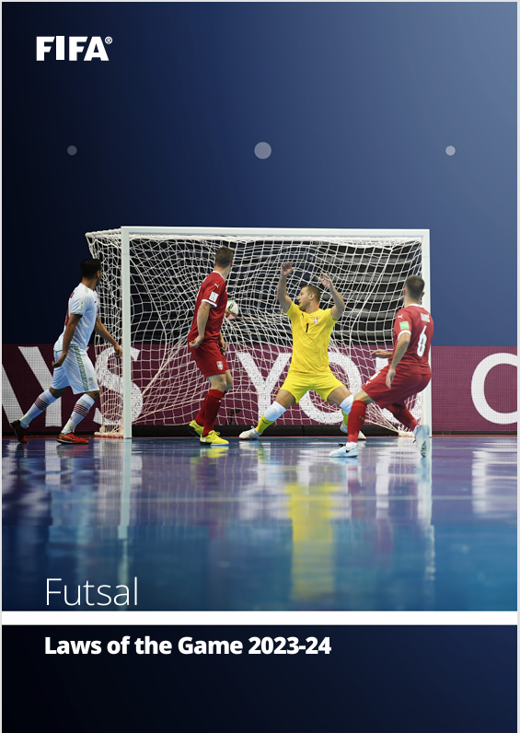
https://assets.the-afc.com/downloads/referees/FIFA-Futsal-Laws-of-the-Game-2023-24.pdf

COSTS

Schools will be invoiced by QSF in Term1, 2025 for all three gala days and the Champions and Shield Finals Day.
Total cost $800 per team
(covers venue hire, referees, sports trainers, admin fees)
Teams that do not qualify for the Champions or Shield Finals Day will be reimbursed.

REFEREES

1 -2 FQ Referees will be supplied for all matches.

DISCIPLINE COMMITTEE
A discipline committee of 3 teachers will be selected before the start of the season that will decide on all consequences from disciplinary reports. Incident report sheets can be found on the QSF Website and must be completed by both coaches and sent to the committee by the end of the following day after the match. A Disciplinary Spreadsheet to track “cautions” will be available on the QSF website.

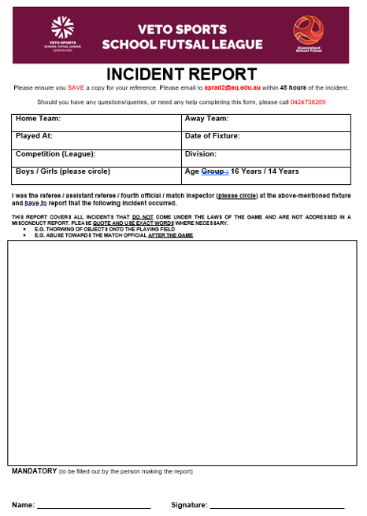
RESULTS and TABLES

All results for Gala Day Conference matches will be recorded on the Referee Match templates and then transferred and recorded on “Squadi”.

There will be a “10 goal” max winning GD applied to all matches.

Results for all matches and updated tables can be found on “Squadi” and results will be updated after each gala day.
Squadi guides available on the QSF website

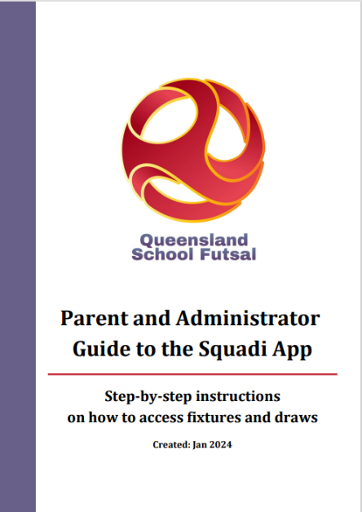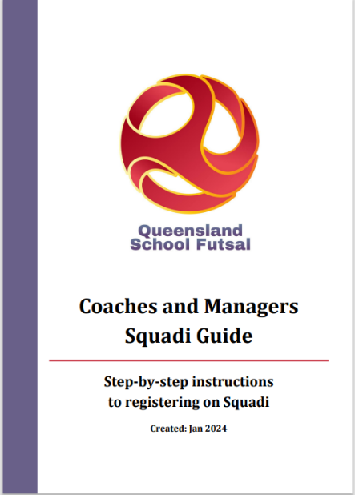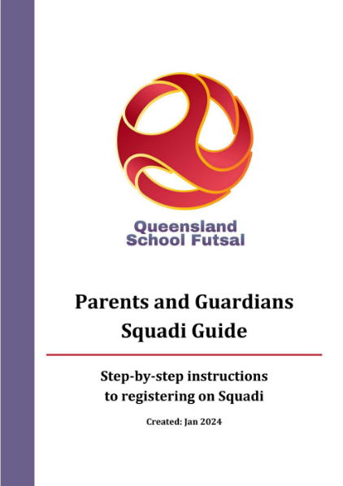
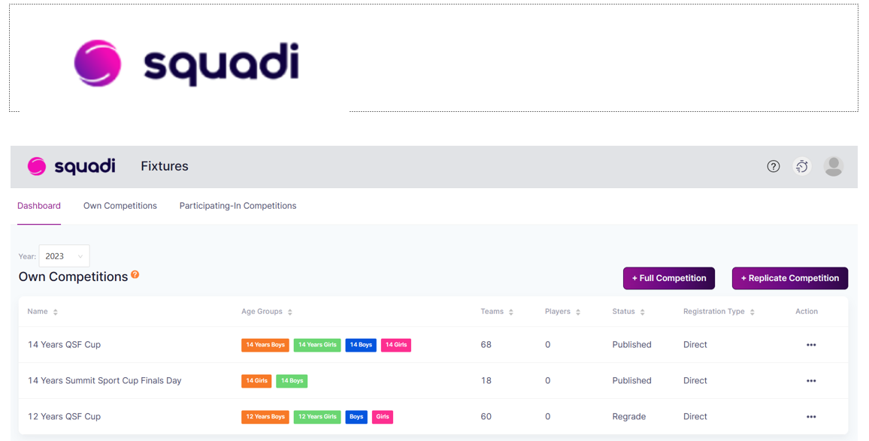

DOCUMENTS
All SFL documents can be found on the QSF Website page



QSF Website – queenslandschoolfutsal.com

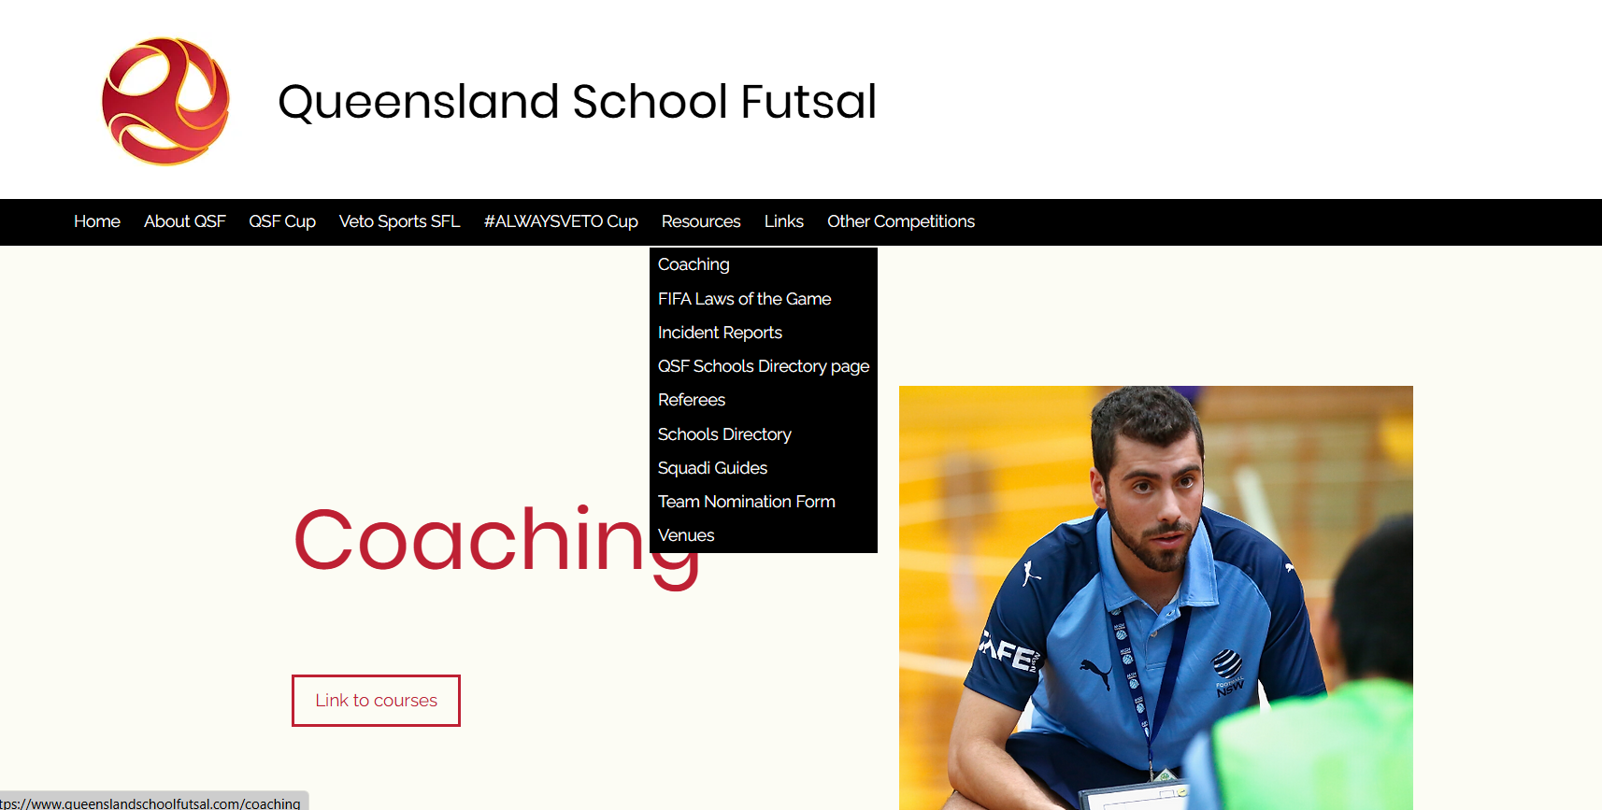

TEAM LISTS
It is requested that schools complete the QSF competition team list form with names, birthdates and principals’ signature and be sent to the convenors as soon as nomination is confirmed (admin@salatimefc.com)

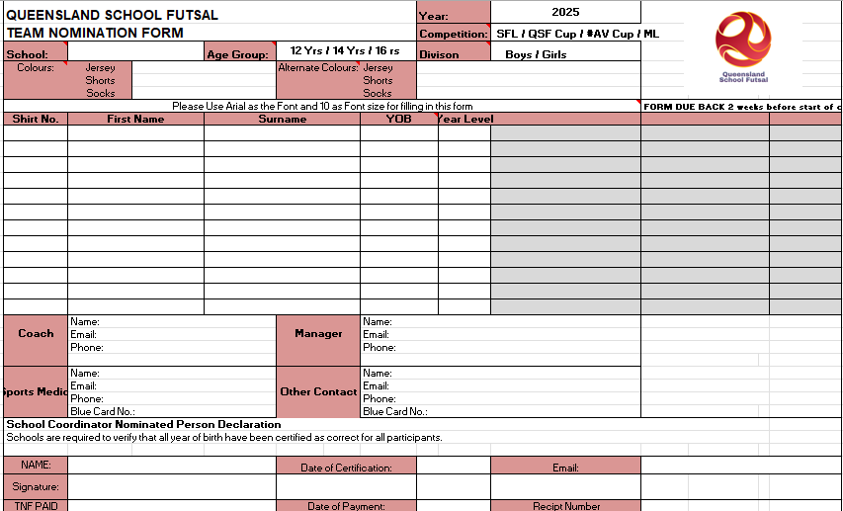

SQUAD LISTS
It is requested that schools prove “School Squad lists” completed with names, birthdates and photos and sent to the convenors (admin@salatimefc.com)

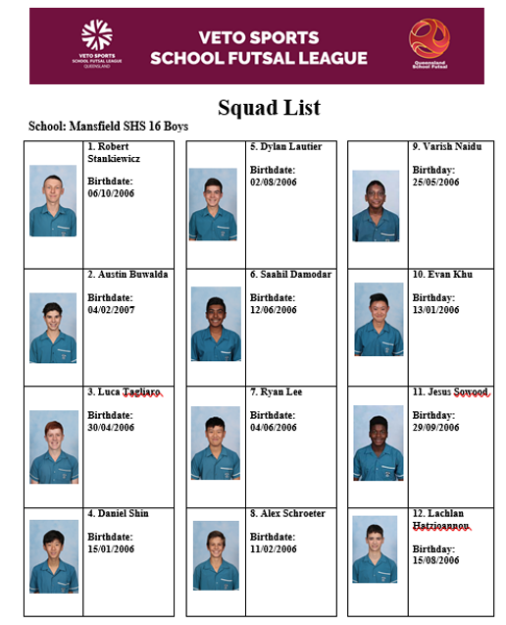

COMMUNICATION
All Coaches and managers are required to join for the QSF WhatsApp group for quick communication purposes before and during the season and will provide updated results, Contact points and news

QSF WhatsApp Group


STAFF
Competition Convenor Referee Coordinator
Alan Pradella Fiona Stevenson


Match Day Coordinators (admin@salatimefc.com)
Raul Ocan Villegas Gervais Morton


SOCIAL MEDIA
QSF has a Facebook page and Instagram account for results posts, videos and general advertising purposes. We would like everyone to invite school staff, students, parents and friends to follow the pages.
We also encourage coaches and managers to complete the “Player” and “Coach” Profiles and forward them to the QSF Social Media Coordinator – Matt Pickham at mpick68@eq.edu.au

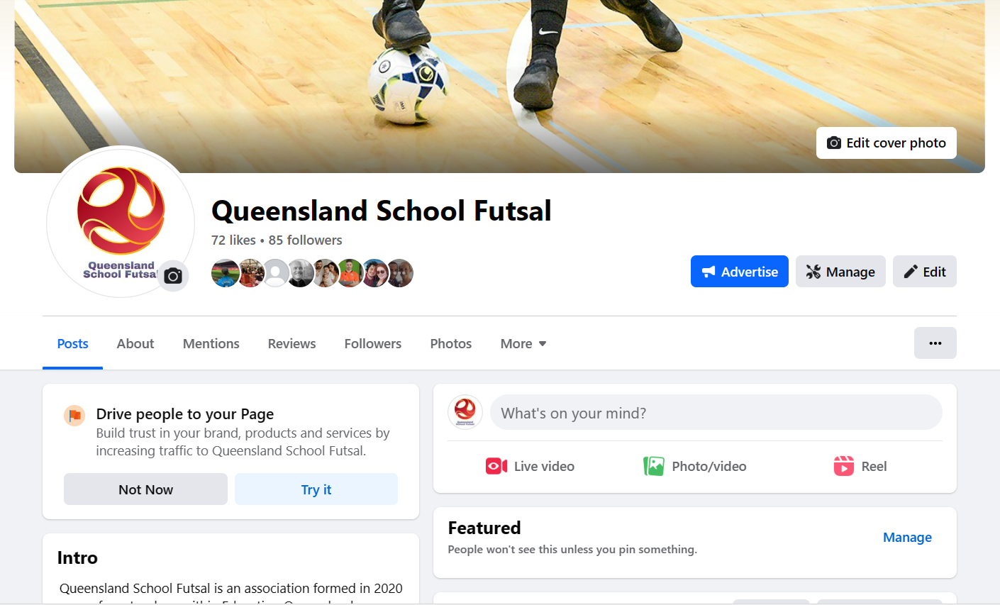


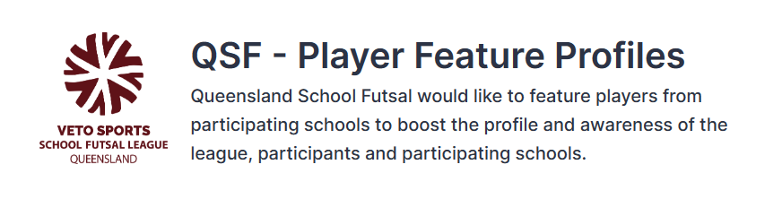
A QSF – Player Feature profile form will be available on the QSF website. Please fill in the questions on behalf of one player who participates in the VETO Sports SFL to be highlighted by QSF on the social media channels. Each school will be featured once throughout the year.
This form must be supplied via email with an image of the feature player – a headshot or action shot. Preferably in portrait version
By submitting this form, you accept that the player and their guardian has given their permission to be featured and for their image to be shared on QSF social media channels and/or the QSF website.
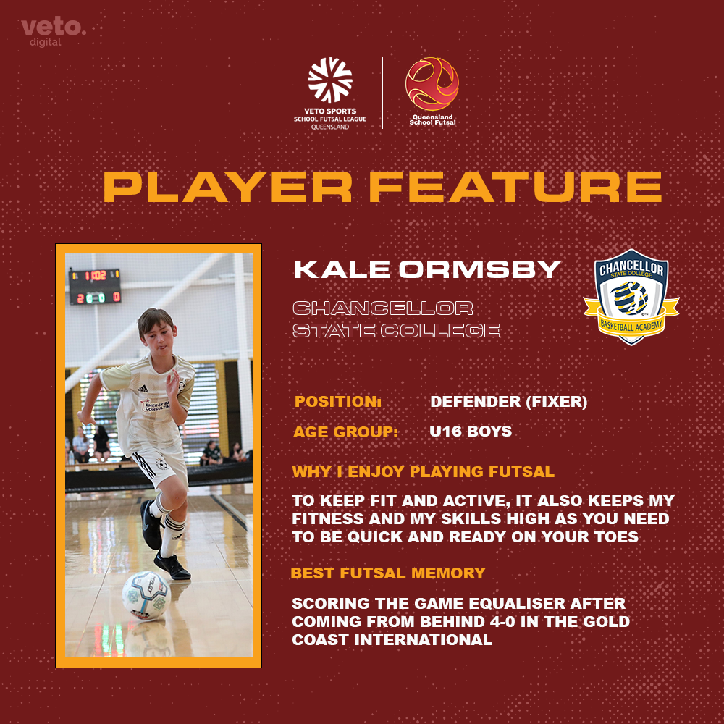
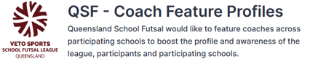
A QSF – Coach Feature profile form will be available on the QSF website. Please fill in the questions on behalf of one teacher or HOD who participates in the VETO Sports SFL to be highlighted by QSF on the social media channels. Each school will be featured once throughout the year.
This form must be supplied via email with an image of the feature player – a headshot or action shot. Preferably in portrait version
By submitting this form, you accept that the player and their guardian has given their permission to be featured and for their image to be shared on QSF social media channels and/or the QSF website.
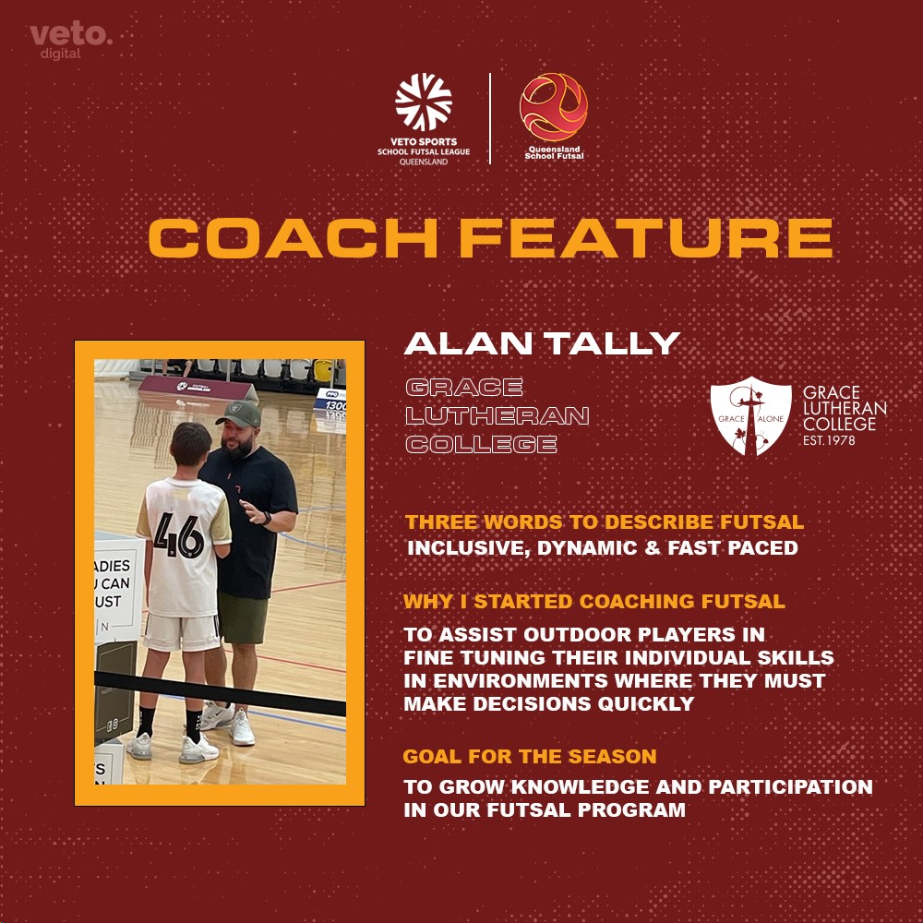
SPONSORS
VETO SPORTS are the official sponsors of the SFL and will supply match balls and official’s polos with SFL logo and School crests. VETO Sports can supply team uniforms and all Futsal related training equipment
Trophies, Medals and Awards
Conference Premiers will receive a Perpetual Premiers trophy and a take-home trophy

Veto Sports Champions will receive the Veto Sports Perpetual and a take-home trophy. Champions, Runners up and 3rd place getters will receive medals

Veto Sports Shield winners will receive the Veto Sports Perpetual trophy.
Champions, Runners up and 3^{rd.} place getters will receive medals

A Veto $50 voucher will be awarded to the Player of the Grand Final








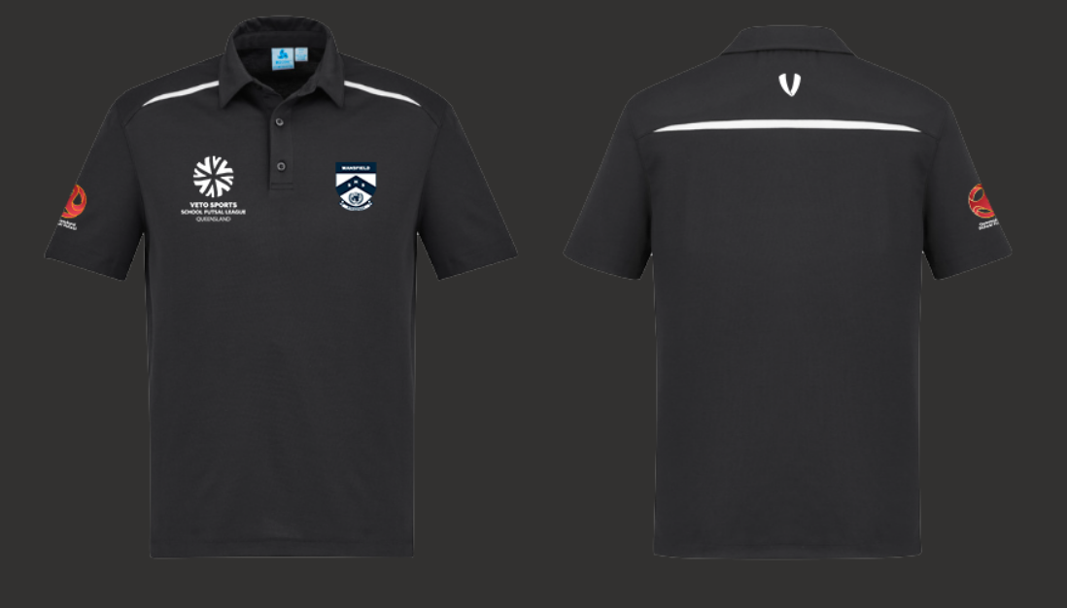

All schools are provided with 2 FREE polo shirts which includes the school logo heat pressed on the polo with the Queensland School Futsal logo.
Additional polo shirts are $30 inc GST each.

