Summit Sport Cup - Quarter Final Draw

Boys Quarter Final Draw
Quarter Final 1 |  |  | John Paul College | Vs |  | Wisdom College
Quarter Final 2 |  |  | Chancellor S Col | Vs | 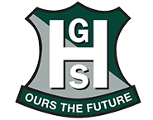 | The Gap SHS
Quarter Final 3 |  |  | Assisi College | Vs |  | Highfields SS College
Quarter Final 4 |  | 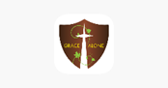 | Grace College | Vs |  | Shalom College
Girls Quarter Final Draw

Quarter Final 1 |  |  | Pimpama SS Coll | Vs |  | The Gap SHS
Quarter Final 2 |  |  | Islamic Coll Bris | Vs | 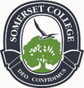 | Somerset College
Quarter Final 3 |  |  | Chancellor S Coll | Vs | 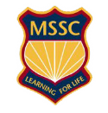 | Murrumba SSC
Quarter Final 4 |  | 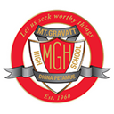 | Mt Gravatt SHS | Vs | 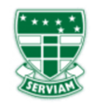 | St Ursula's College

