**2025**

**ASF CUP**

**

**Information**

**Table of Contents**

|  |  |  |
| --- | --- | --- |
| **Competition details** | **………………………………………..** | **3** |
| **Age Groups, Formats, Nominations, Draws** | | |
| **State Qualifiers** |  |  |
| **Peninsula/Northern** | **…………………………………………** | **7** |
| **Wide Bay/Capricornia** | **………………………………………..** | **8** |
| **Southeast Queensland**  **Other States** | **………………………………………..** | **9** |
| **Match Rules** | **………………………………………..** | **10** |
| **Costs/ Referees** | **………………………………………..** | **13** |
| **Results** | **………………………………………..** | **14** |
| **Documents** | **………………………………………..** | **15** |
| **Team Lists** | **………………………………………..** | **16** |
| **Squad Lists** | **……………………………………….** | **17** |
| **Communication** | **……………………………………….** | **18** |
| **Staff** | **……………………………………….** | **19** |
| **Social media** | **……………………………………….** | **20** |
| **Sponsors** | **……………………………………….** | **21** |
| **2025 QSF Calendar** | **……………………………………….** | **22** |
|  |  |  |
|  |  |  |
|  |  |  |

**Competition Details**

**This is an Australian schools 12 years (primary school) and 14 years, boys and girls 3 - Day Futsal tournament organized be the QSF committee to bring together the best school Futsal teams in Australia.**

**The ASF Cup provides the opportunity for all schools to participate and compete against other schools within their district, region, state and Australia.**

**The 3 day tournament allows teams of differing levels to play each other on Day 1 and then the “Cup and “Shield” format disseminates teams into pools of similar standards on Day 2 which then allows all teams to win a trophy and medals.**

**Although the ASF Cup is open to all schools in Australia, only the top 2 Girls and Boys teams in each age division who have won their respective state competitions will qualify to enter, but as this is the inaugural ASF Cup, nominations will be open to all teams in states where a qualifying tournament does not exist now. (Schools may be asked to play qualifying matches to qualify in these states).**

**AGE GROUPS: Boys and Girls**

**12 Years (Students must be in Year 6 or below and cannot turn 13 or older in 2025) Girls** may play in the Boys division only if the school does not have a representative Girls team

**14 Years (Students cannot turn 15 or older in 2025)**

**ASF Cup & Shield - Tournament Format**

**3 Day QSF Cup Format**

**Once nominations are finalized, the 16 schools will be randomly placed in 4 Pools of 4 teams.**

**On Day 1** **each team in their respective pools will play each other once. At the end of Day 1 the 8 first and second placed teams from the 4 pools will then be placed in 2 Cup Pools of 4 teams. On Day 2 each team in their respective “Cup” pools will play each other once. On Day 3, the top 2 teams in the Cup Pools will play cross over semifinals and the winners will progress to the Cup Grand final while the losers will playoff for bronze medals.**

**Teams finishing third and fourth in the Day 1 Pools will compete in the Day 2 "Shield" competition in the same format as the “Cup” competition.**

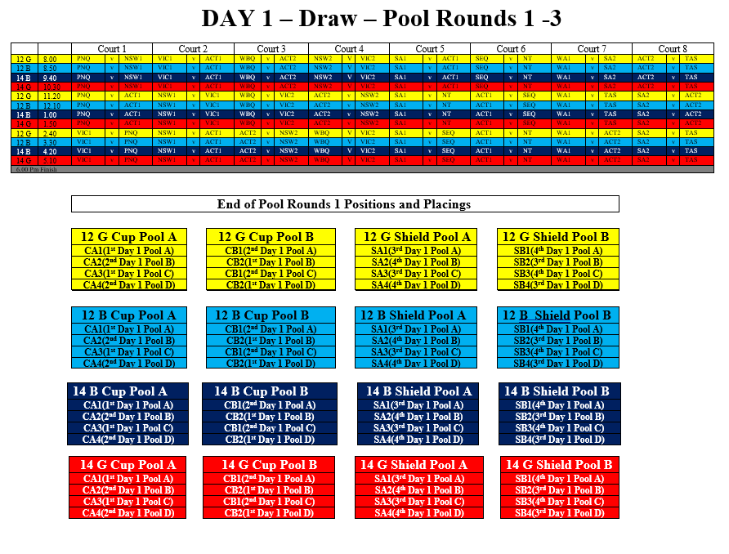

**NOMINATIONS**

**Nomination forms are available on the QSF website and will close at the end of Week 10, Term 2, 2025.**

**All ASF Cup Divisions will have maximum of 16 Boys and 16 Girls teams, so schools nominating after the competition limits have been filled, will be placed on "Reserve" lists.**

**Competition Invoices will be sent as nominations are received and will then be finalised after nomination fees payment.**

**DRAWS**

**The Draws for all 4 Divisional ASF Cups will be made after nominations have been finalised, and available in Week 1, Term 3, 2025 on the QSF Website.**

**Peninsula / Northern QSF Cup Details  
VENUE: Redlynch Indoor Sports Centre – 3 Chelsea Lane Redlynch, Cairns**

**FORMAT:**

**The Peninsula / Northern QSF Cup will be a 1 day - 12 - team tournament comprised of 3 Pools of 4 with all teams playing 3 round matches followed by Semifinals, Finals and Playoff matches.**

**Boys and girl’s rounds will be played together on the day.**

**Teams finishing top of their pools, and the best placed 2nd will qualify for the Cup playoffs and teams finishing second and 2 best placed thirds qualify for the Shield playoffs.**

**All other Teams will play positional playoffs**

**DATES:**

|  |  |  |  |
| --- | --- | --- | --- |
| **14 Years** |  |  |  |
| **Boys** | **QSF Cup** | **Thursday** | **19th June** |
| **Girls** | **QSF Cup** | **Thursday** | **19th June** |
|  |  |  |  |
| **12 Years** |  |  |  |
| **Boys** | **QSF Cup** | **Friday** | **20th June** |
| **Girls** | **QSF Cup** | **Friday** | **20th June** |

**Wide Bay / Capricornia QSF Cup Details  
VENUE:**

**FORMAT:**

**The Wide Bay / Capricornia QSF Cup will be a 1 day - 12 - team tournament comprised of 3 Pools of 4 with all teams playing 3 round matches followed by Semifinals, Finals and Playoff matches.**

**Boys and girl’s rounds will be played together on the day.**

**Teams finishing top of their pools, and the best placed 2nd will qualify for the Cup playoffs and teams finishing second and 2 best placed thirds qualify for the Shield playoffs.**

**All other Teams will play positional playoffs**

**DATES:**

|  |  |  |  |
| --- | --- | --- | --- |
| **14 Years** |  |  |  |
| **Boys** | **QSF Cup** | **Thursday** | **19th June** |
| **Girls** | **QSF Cup** | **Thursday** | **19th June** |
|  |  |  |  |
| **12 Years** |  |  |  |
| **Boys** | **QSF Cup** | **Friday** | **20th June** |
| **Girls** | **QSF Cup** | **Friday** | **20th June** |

**Southeast Queensland Details  
VENUE: Coomera Indoor Sports Centre – Beattie Rd Coomera**

**FORMAT:**

**The Southeast Queensland QSF Cup will be a 2 day - 16 - team tournament comprised of 4 Pools of 4 with all teams playing 3 round matches on Day 1.**

**Day 2 - Quarterfinals, Semifinals, Finals and Playoff matches.**

**Boys and girl’s rounds will be played together on the day.**

**Teams finishing in 1st and 2nd position of their pools at the end of Day 1 round matches will qualify for the Cup playoffs and teams finishing 3rd and 4th at the end of their Day 1 pools will qualify for the Shield playoffs.**

**DATES:**

|  |  |  |  |
| --- | --- | --- | --- |
| **14 Years** |  |  |  |
| **Boys** | **QSF Cup- Day 1** | **Monday** | **15th Sept** |
|  | **QSF Cup – Day 2** | **Tuesday** | **16th Sept** |
| **Girls** | **QSF Cup- Day 1** | **Monday** | **15th Sept** |
|  | **QSF Cup – Day 2** | **Tuesday** | **16th Sept** |
|  |  |  |  |
| **12 Years** |  |  |  |
| **Boys** | **QSF Cup- Day 1** | **Wednesday** | **17th Sept** |
|  | **QSF Cup – Day 2** | **Thursday** | **18th Sept** |
| **Girls** | **QSF Cup- Day 1** | **Wednesday** | **17th Sept** |
|  | **QSF Cup – Day 2** | **Thursday** | **18th Sept** |

**All Other Interstate Qualifying Details  
The dates, format and venue information for all other state qualifying tournaments will be posted one received.**

**Procedures and Rules**

|  |  |
| --- | --- |
| 1. | Each game shall consist of two periods of 20 minutes with 5 min half time break |
| 2. | Normal "FIFA" Futsal rules will apply to all matches (except that the clock will not be stopped every time the ball goes out of play and restarted when play resumes) |
| 3. | Teams are entitled to a one-minute time-out in each period. A team that does not request a time out in the first half of the match is only entitled to one time-out during the second half. Time outs can be taken at **any time** during both halves. The clock will stop for all timeouts. In the last 2 minutes of the match, if referees believe teams are wasting time intentionally, they have the right to stop the clock. |
| 4. | A maximum of 10 players are allowed in each team on match day. (School squads can have a maximum of 24 players.)  All 10 players can be used in unlimited interchange. All substitutions are to be Rolling substitutions. Substitutions may be made at any time, whether the ball is in play or not, but only in the specially demarcated substitution zones. (G/K's should only be substituted during a stoppage in play). |
| 5. | Yellow Cards - Two yellow cards in the same game will mean the player is sent from the field an automatic suspension for next game plus any punishment meted by Disputes committee. **Two yellow cards awarded in separate matches** will also mean suspension of one match.  Red cards - Sent off and automatic suspension for next game plus any punishment meted by the Disputes committee.  (Dispute committee will be the gala day convenors and the referee coordinator) |
| 6. | All players must wear non marking soled shoes, shin pads covered by long socks and matching numbered shirts and shorts (except goalkeepers). (referees can prevent players entering the court if not dressed correctly)  If there is a clash of colors, it is the "HOME" teams (first named on the draw) responsibility to have an alternate strip or wear bibs. |
| 7. | Home teams will run left to right of the team benches and kick off all matches. |
| 8. | Any Team not on court 5 mins after the scheduled kick off time will start with a 2-goal deficit. ie., 2 goals will automatically be awarded to the opposition. If there are circumstances out of the team’s control, then the match time will be reduced to allow a result |
| 9. | If a match is drawn at full time in a **Quarter Final, Semi Final** or **Grand Final** there will be two periods of 5 minutes extra time with no intervals or time outs, then FFA rules of penalty kicks to decide the winner. There are no time outs in “extra time” |
| 10. | There will be a “10 Goal Max Goal difference for all results ie., a 16–1 result will be entered as 11-1. |

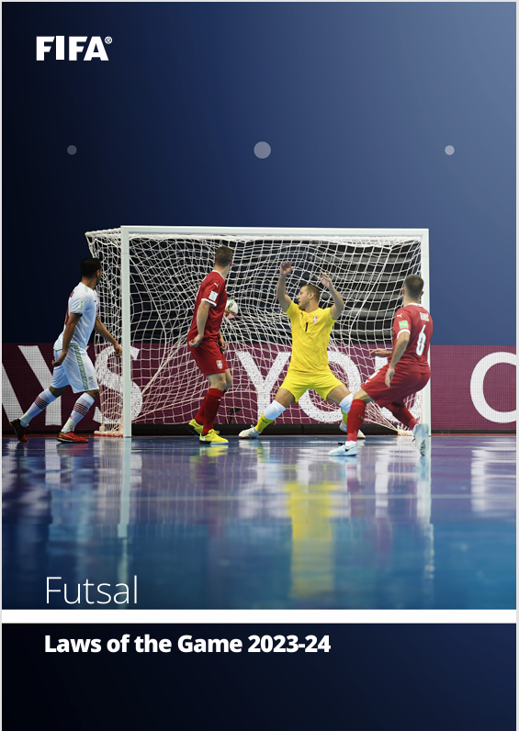

**https://assets.the-afc.com/downloads/referees/FIFA-Futsal-Laws-of-the-Game-2023-24.pdf**

**COSTS**

**Schools will be invoiced by QSF once nominations are received in 2025**

**Approx $300 per team**

**(covers venue hire, referees, sports trainers, admin fees)**

**REFEREES**

**1 -2 FQ Referees will be supplied for all matches.**

**DISCIPLINE COMMITTEE**

**A discipline committee of 3 teachers will be selected before the start of the season that will decide on all consequences from disciplinary reports. Incident report sheets can be found on the QSF Website and must be completed by both coaches and sent to the committee by the end of the following day after the match**

**RESULTS and TABLES**

**All results for the tournament matches will be recorded on the Referee Match templates and then transferred to a Results sheet in the foyer of the venue.**

**There will be a “10 goal” max winning GD applied to all matches.**

**Results for all matches and updated tables can be found on QSF Website and results will be updated on the website.**

**A Disciplinary Spreadsheet to track “cautions” will be available on the QSF website.**

**TROPHIES, MEDALS and AWARDS**

**ASF Cup champions will receive a Perpetual Premiers trophy and a take-home trophy**

**Runners up and 3rd place getters will receive medals**

**ASF Cup Shield winners will receive the Veto Sports Perpetual trophies. Runners up and 3rd. place getters will receive medals**

**DOCUMENTS**

**All ASF Cup documents can be found on the QSF Website page**

**QSF Website** – queenslandschoolfutsal.com

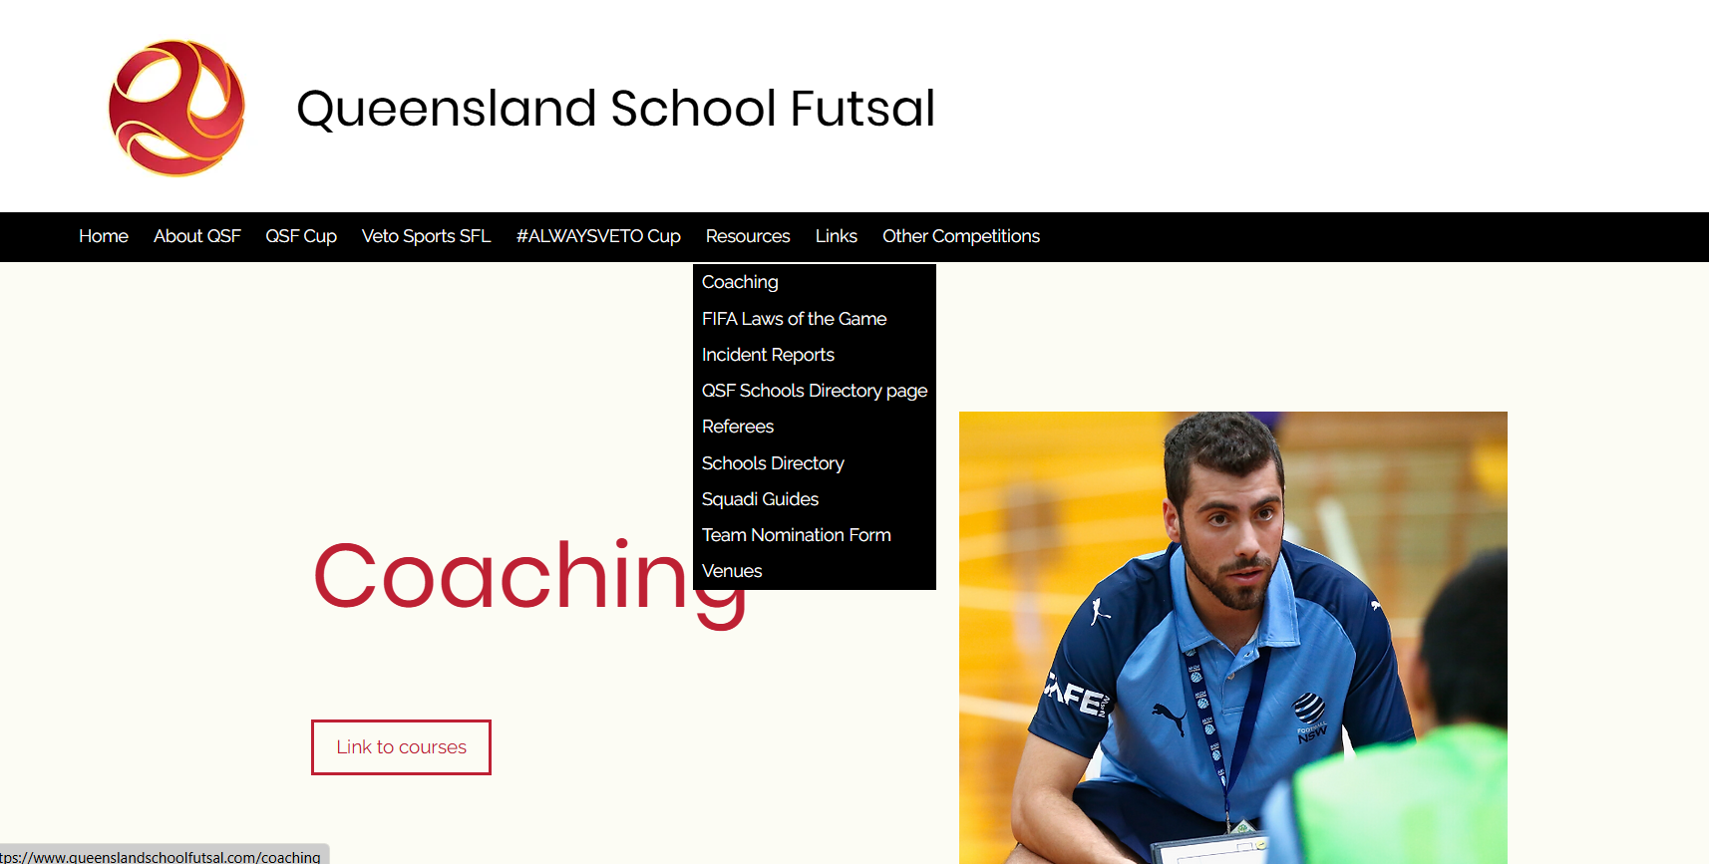

**TEAM LISTS**

**It is requested that schools complete with names, birthdates and principals’ signature and be sent to the convenors as soon as nomination is confirmed (**[**admin@salatimefc.com**](mailto:admin@salatimefc.com)**)**

**SQUAD LISTS**

**It is requested that schools prove “School Squad lists” completed with names, birthdates and photos and sent to the convenors (**[**admin@salatimefc.com**](mailto:admin@salatimefc.com)**)**

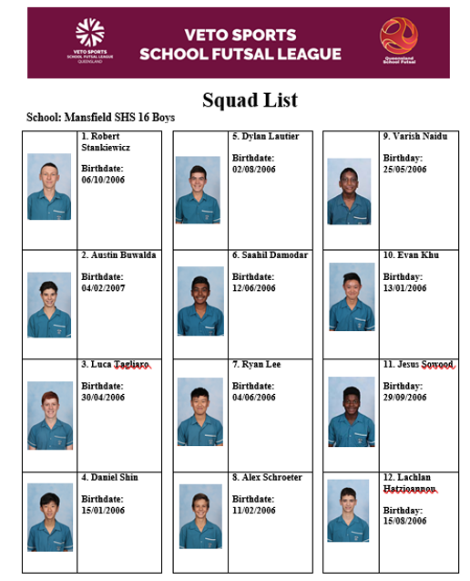

**COMMUNICATION**

**All Coaches and managers are required to join for the QSF WhatsApp group for quick communication purposes before and during the season and will provide updated results, Contact points and news**

**QSF WhatsApp Group**

**STAFF**

**Competition Convenor Referee Coordinator**

**Alan Pradella Fiona Stevenson**

**Match Day Coordinators (**[**admin@salatimefc.com**](mailto:admin@salatimefc.com)**)**

**Raul Ocan Villegas Gervais Morton**

**SOCIAL MEDIA**

**QSF has a Facebook page and Instagram account for results posts, videos and general advertising purposes. We would like everyone to invite school staff, students, parents and friends to follow the pages.**

**We also encourage coaches and managers to complete the “Player” and “Coach” Profiles and forward them to the QSF Social Media Coordinator – Matt Pickham at mpick68@eq.edu.au**

**SPONSORS**

**ACADEMY ONE FOOTBALL TOURS are the official sponsors of the QSF Cup.**

**Our International Development Tours cater to both boys and girls football squads, providing bespoke travel packages designed in conjunction with team coaches & management.**

**We cover everything from destination selection and football itinerary (including pro-club training, pro-club match tickets, competitive fixtures & ground bookings), flights and accommodation, transport, meal planning, translators and leisure activities.**

