
Faith Lutheran College

Address |  | 15 Beveridge Rd, Thornlands | School Finish Time |  |  | 3.10pm
Phone |  |  | Transport |  |  | Private Car/ Bus
Coordinator |  | Nicole Hutchinson | Nhutchinson@flcr.qld.edu.au |  |  | 0421212259
Home Colours |  | Navy/Gold | Away Colours |  |  | TBC
Coaches |  |  | Email |  |  | Mobile
16 Boys |  | Matthias Burke | mburke@flcr.qld.edu.au |  |  | 0423821996
16 Girls |  | Andrew Droney | Adroney@flcr.qld.edu.au
14 Boys |  | Matthias Burke | mburke@flcr.qld.edu.au
14 Girls |  | Andrew Droney | Adroney@flcr.qld.edu.au
Venue Details
Court 1 |  | Hayshed 1 | Court 2 |  | Hayshed 2
Address |  | As above | As above
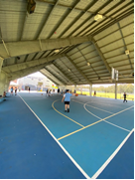 |  |  | 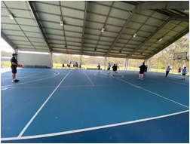
Size | 30m x 15 m |  | Size | 30m x 15m

