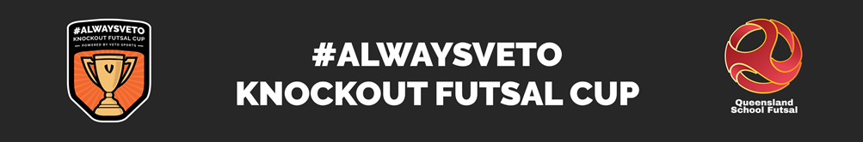
#ALWAYSVETO 14 Years Knockout Futsal Cup
Round 1 - Results
Metropolitan East / North
5 | Mabel Park SHS | v | 0 | Citipointe CC | Boys | 5 | Loganlea SHS | v | 0 | Brisbane South SSC
5 | Mabel Park SHS | v | 0 | Citipointe CC | Girls | 5 | Loganlea SHS | v | 0 | Brisbane South SSC
 | Bye | v |  | Redeemer LC | Boys | 5 | The Gap SHS | v | 0 | Shailer Park SHS
 |  |  |  |  | Girls | 5 | The Gap SHS | v | 0 | Shailer Park SHS
0 | Faith L College | v | 5 | St James College | Boys | 5 | Mansfield SHS | v | 0 | Mt Gravatt SHS
0 | Faith L College | v | 5 | St James College | Girls | 5 | Mansfield SHS | v | 0 | Mt Gravatt SHS
 | Bye | v |  | Fortitude V SSC | Boys | 4 | Murrumba SSC | v | 3 | Brisbane Adv College
 |  |  |  |  | Girls | 8 | Murrumba SSC | v | 1 | Brisbane Adv College

South Coast
5 | Hillcrest Coll | v | 0 | Coomera Ang Coll | Boys | 0 | Trinity College | v | 5 | Beenleigh SHS
5 | Hillcrest Coll | v | 0 | Coomera Ang Coll | Girls | 0 | Trinity College | v | 5 | Beenleigh SHS
0 | Robina SHS | v | 5 | Pimpama SSSC | Boys | 5 | Somerset College | v | 0 | St Francis College
0 | Robina SHS |  | 5 | Pimpama SSSC | Girls | 5 | Somerset College | v | 0 | St Francis College
 | Bye | v |  | St Andrews Coll | Boys | 5 | John Paul College | v | 2 | Kimberley College
 |  |  |  |  | Girls | 6 | John Paul College | v | 7 | Kimberley College
0 | Kings College | v | 5 | Foxwell Sec Coll | Boys | 1 | Livingstone Coll | v | 8 | Assisi College
0 | Kings College | v | 5 | Foxwell Sec Coll | Girls | 5 | Livingstone Coll | v | 0 | Bye

Metropolitan West
1 | Isl Coll Bris | v | 3 | Calamvale College | Boys |  | Wisdom College | v |  | Bye
8 | Isl Coll Bris | v | 1 | Calamvale College | Girls | 0 | Wisdom College | v | 5 | Brigidine College
 | St Peters Coll | v |  | Bye | Boys |  | Bye | v |  | Lowood SHS
 |  |  |  |  | Girls
 | Bye | v |  | Indooroopilly SHS | Boys | 10 | Ripley Val SHS | v | 0 | Bremer SHS
 |  |  |  |  | Girls | 4 | Ripley Val SHS | v | 1 | Bremer SHS

