
School |  | St Peter Claver College
Address |  | 10 Old Ipswich Road Riverview Q 4303 |  | School Finish Time |  |  |  | 2:55 pm
Phone |  | (07) 3810 5900 | Transport |  |  |  | Coaster Bus
Name email Mobile
Coordinator |  | Jarrod Hollands | Jarrod.Hollands@bne.catholic.edu.au |  |  |  | 0468942755
Coaches
16 Boys |  | Brentyn Walter | brentyn.walter@bne.catholic.edu.au |  |  |  | 0401 584 404
16 Girls |  | Dallas Murphy | damurphy@bne.catholic.edu.au |  |  |  | 0414 895 213
14 Boys |  | Brentyn Walter | brentyn.walter@bne.catholic.edu.au |  |  |  | 0401 584 404
14 Girls |  | Dallas Murphy | damurphy@bne.catholic.edu.au |  |  |  | 0414 895 213
Venue Details
Court 1 |  | St Peter Claver College VPC | Court 2 |  |  | Nil
Address |  | 10 Old Ipswich Rd Riverview
Photo  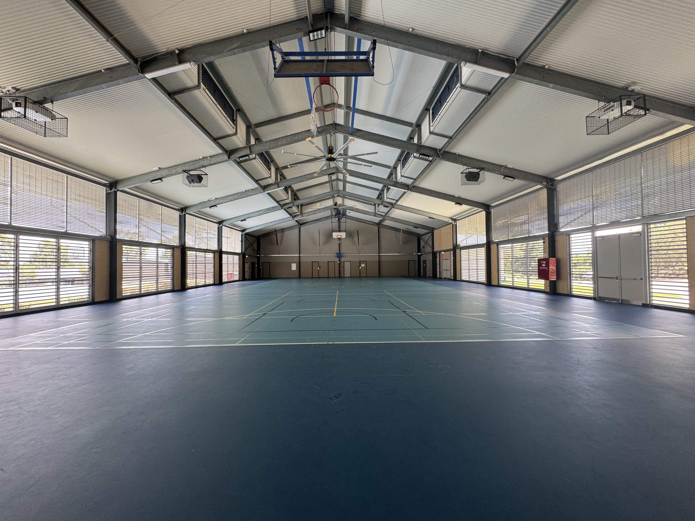 |  |  | Photo
Size | 30.5 m x 15.25 m |  | Size |  | m x m
Other Facilities and notes
Toilets and change rooms attached to court.

