Queensland School Sport
 [Grab reader’s attention with a great quote from the document or use this space to emphasize a key point. To place this text box anywhere on the page, just drag it.]
 [Grab your reader’s attention with a great quote from the document or use this space to emphasize a key point. To place this text box anywhere on the page, just drag it.]
and

Football Queensland

present

The

Years 7 Boys and Girls

QSS FUTSAL CUP
SEQ Champions Carnival

Eagles Indoor Sports Centre
Sport Centre
Thursday 18th July 2019

2019 Champions

Albany Creek SHS – Met North (North West District)

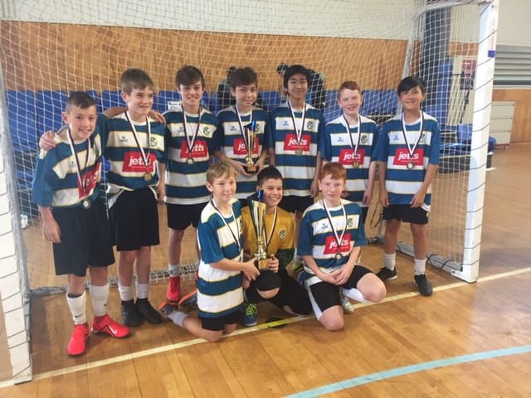

Islamic Coll of Brisbane– Met West (East district)

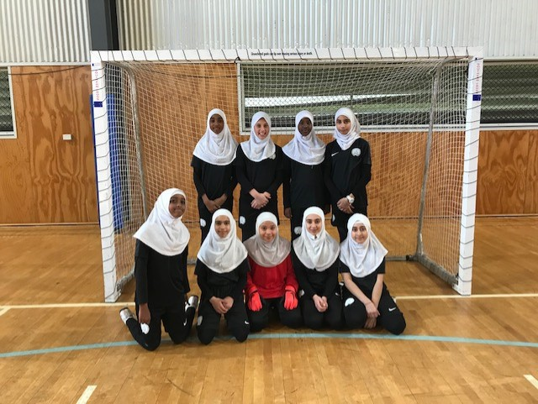

Carnival Draw

Year 7 Boys & Girls – QSS Futsal Cup - SEQ Carnival
BOYS |  |  |  | GIRLS
Shailer Park SHS (South Coast) |  |  |  | Calvary CC (South Coast)
St Peter Claver College (Met West) |  |  |  | Brisbane Islamic College (Met West)
Mansfield SHS (Met East) |  |  |  | Mansfield SHS (Met East)
Albany Creek SHS (Met North) |  |  |  | Prince of Peace (Met North)

Thursday 18th July

8.00 | Coaches / Managers Meeting
8.15 | Players Briefing
 | Court 1 |  |  |  | Court 2
8.30 | Shailer park | V | St Peter Claver |  | Mansfield | V | Albany Creek
9.15 | Calvary | V | Bris Islamic Coll |  | Mansfield | V | Prince of Peace
10.00 | St Peter Claver | V | Mansfield |  | Albany Creek | V | Shailer park
10.45 | Bris Islamic Coll | V | Mansfield |  | Prince of Peace | V | Calvary
11.30 | Shailer park | V | Mansfield |  | St Peter Claver | V | Albany Creek
12.15 | Calvary | V | Mansfield |  | Bris Islamic Coll | V | Prince of Peace
1.00 | Announcement of QSS Futsal Cup – SEQ Champion teams
1.30 | End of Carnival

All matches played with full international rules - 20 min halves with one “one minute “ time out per half (Half time will 5 minutes)

Sports med, referees and match balls will be supplied

Warmups fields are available outside the venue

The QSS Futsal Cup is a Queensland Secondary Schools endorsed Futsal competition organized by the QSS Futsal committee for Year 7 teams open to all schools in the Metropolitan and South Coast Regions. All Schools are invited to nominate a Boys and Girls Year 7 team.

The QSS Futsal Cup Competition has 3 Phases:-

Phase 1 – District Champions – A Year 7 Boys and girls District Champion school is decided from either
- A District competition that is played regularly in Term 1 with a District Grand Final to be decided by Week 2 of Term 2
- A Gala Day Carnival organized by the District convenor in Term 2 to decide the District Champions

Phase 2 – Regional Champions – A Year 7 Boys and girls Regional Champion school is decided from the One Day “Round Robin” Regional Champions Carnival in Week 3, of Term 2

Phase 3 – SEQ Champions – The South East Queensland Year 7 Boys and girls Champion school is decided from the One Day “Round Robin” SEQ Champions Carnival on Thursday 18 July, Week 1, of Term 3 at Eagles Sports Indoor Centre, Weedon st Mansfield

CARNIVAL PROCEDURES
Statement
This is a “One day” carnival for players for students in year 7 of the year of competition with the sole purpose of selecting a Metropolitan East Regional Champion team that will compete at the South East Queensland Championship Carnival at Eagles Sports Indoor sports stadium on Wednesday 22nd May. A Perpetual Trophy and medals will be awarded to the winning schools.

Round robin Matches

Points:- 3 Pts - Win , 2 Pts - Score draw, 1 Pt - Scoreless draw, 0 Pts - Loss
Positions in Pools and Overall standings will be allocated by
(a)overall points (b) goal diff (c) goals for (d) results of round matches (e) Number of R/Y cards

QSS Futsal Cup – Regional & SEQ Carnival Rules
(1) Game time
(a) Matches will comprise 2 periods each of 20 minutes actual playing time.
(b) There will be no extra time added on in Round matches.

(2) Time outs
(a) Teams are entitled to a one-minute time-out in each period. (Half time may be reduced to accommodate time outs )
(b) A team that does not request a time-out in the ﬁrst half of the match is only entitled to one time-out during the second half.
(c) There are no time-outs in extra time.

(3) Players and substitutions
(a) Team squads can be up to a maximum of 10 players, each consisting of not more than ﬁve players (a goalkeeper and four outfield players) and five substitutes.
(b) There is no restriction on the number of substitutions during a match.
(c) Substitutions may be made at any time, whether the ball is in play or not, but only in the specially demarcated substitution zones.
(d) Goalkeepers should only be substituted during a stoppage in play.
(e) Players must wear non marking soled shoes, shin pads covered by long socks and 'sport' shirt and shorts
(f) All players are to wear Numbered shirts of the same colour. If there is a clash of colours it is the "AWAY" teams (first team on draw) responsibility to have an alternate strip or wear bibs.
(g) If in the event of a player being sent from the field, a substitute player may replace the sent-off player and enter the pitch two full minutes after the sending-off. They may, however, enter the pitch before the two minutes have elapsed should their team concede a goal while a player down.
(h) Goalkeepers have only four seconds in which to play the ball, with either their hands or feet, and may not touch it again if it has been deliberately played to them by a team-mate without an opponent playing or touching it or has crossed the halfway line (2 Touch).
(i) Goalkeepers are free to play anywhere on the pitch and throw the ball the full length of the court.

(4) Fouls and cards
(a) Accumulated fouls are those penalised with a direct free-kick or penalty kick, regardless of whether advantage has been played or not.
(b) 5 accumulated team fouls are allowed each half (per team). Each subsequent foul is rewarded by a 10 metre penalty shot to the opposition team. If a team commits a sixth accumulated foul, the opposing side may take the subsequent free-kick awarded to them without a wall, either from the second penalty mark, which is positioned four metres
behind the first, or from a position even closer to the penalty area if the foul was committed between the goal line and the second penalty mark.
(b) Red cards - Sent off and automatic suspension for next game plus any punishment meted by the Disputes committee.
(c) Yellow Cards - Two yellow cards in the same game will mean player is sent from the field and an automatic suspension for next game plus any punishment meted by Disputes committee. Two yellow cards in different games on the days will also mean suspension.

(5) Goals, kick ins and set plays
(a) A goal CANNOT be scored directly from a sideline kick in, an indirect free kick
or a kickoff (starting or restarting a game).
(b) The whole of the ball must CROSS the whole of the line for the referee to award a
corner, goal, goal clearance etc.
(c) There is a 4 second time limit placed on all set plays (corners, free kicks, etc )

