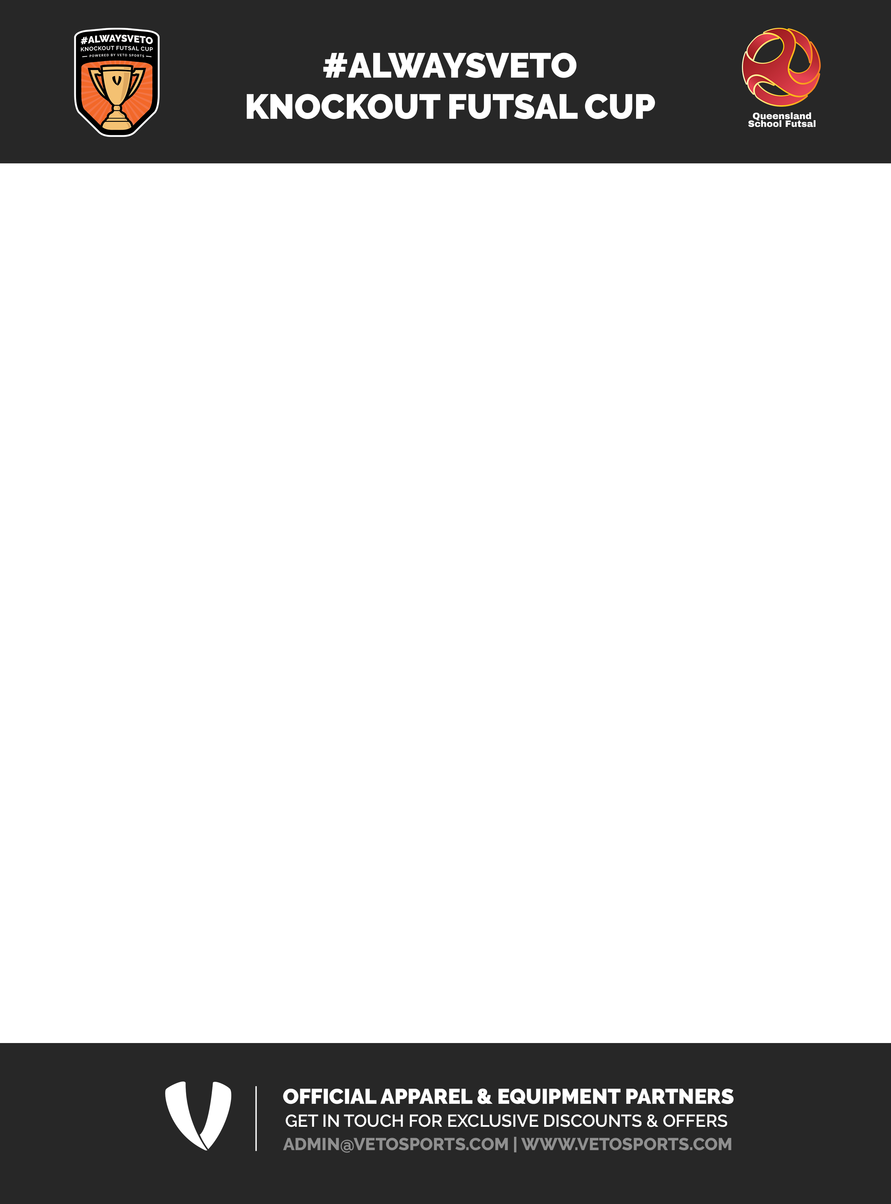
2024 - NOMINATION FORM

School |  |  |  |  |  |  |  |  |  |  |  |  | Conference
Address
Venue Details |  |  |  |  |  |  |  |  |  |  |  |  |  |  |  |  |  | No of courts
O
Invoice email
School Futsal Contacts
Email |  |  |  |  |  |  |  |  |  |  |  | Mobile
Nominated Teams
 |  |  |  |  | Tick
14 & under |  | Boys |  |  |  |  |  | Coach |  |  |  |  |  |  |  | Email
14 & under |  | Girls |  |  |  |  |  | Coach |  |  |  |  |  |  |  | Email
Playing Colors
Jersey |  |  |  |  |  |  | Alt |  |  |  | Shorts |  |  |  |  |  |  |  |  | Socks
Principals Signature
 | I hereby consent for Queensland School Futsal to take photographs of the "#ALWAYSVETO Knockout Futsal Cup teams" and use them for the purpose of promoting Queensland School Futsal on its website and social media.

Tick

Return email to:- ALAN PRADELLA (MANSFIELD SHS) aprad2@eq.edu.au
Nominations close Friday 1 December 2023. Schools will be notified of their acceptance into the #ALWAYSVETO Knockout Futsal Cup and provided with information regarding discounts and offers with VETO Sports.

