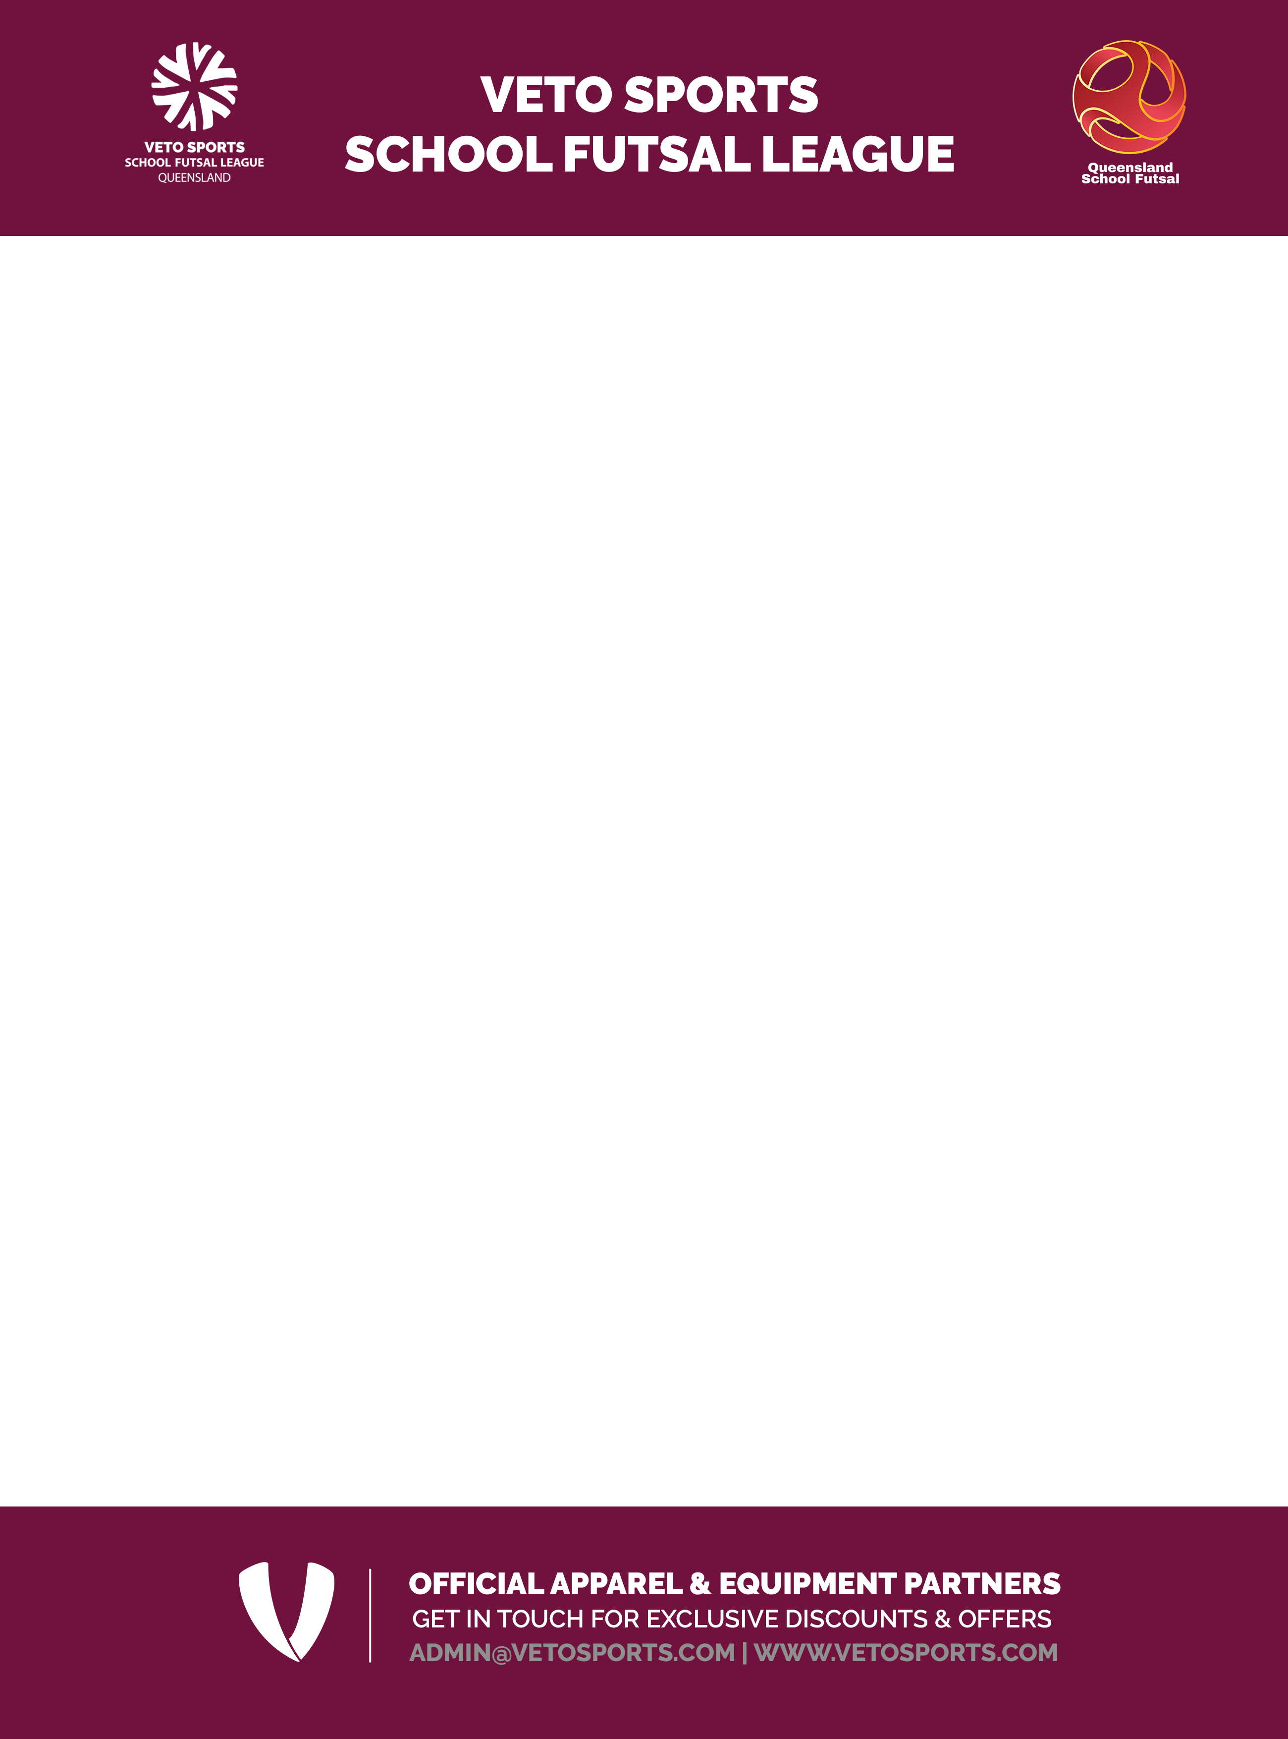

12 Years - Girls & Boys - Southern Conference - Tables & Results

12 Years Boys - Southern Conference

School |  | Code | Played | Won | Drawn | Lost | For | Against | GD | Points
1 | Assisi Catholic Coll | ACC
2 | Cedar Creek SS | CSS
3 | Helensvale SHS | HEL
4 | Hillcrest CC | HCC
5 | Luth Ormeau Rivers | LOR
6 | Ormeau Woods SHS | ORM
7 | Pimpama SSC | PIM
8 | St Andrews College | STA
9 | Somerset College | SOM
10 | Yugumbir SS | YUG
11 | Beaudesert SHS | BEA
12 | Redeemer Luth Coll | RLC

12 Years Girls - Southern Conference

School |  | Code | Played | Won | Drawn | Lost | For | Against | GD | Points
1 | Hillcrest CC | HCC
2 | Luth Ormeau Rivers | LOR
3 | Ormeau Woods SHS | ORM
4 | Pimpama SSC | PIM
5 | St Andrews College | STA
6 | Somerset College | SOM

Results

Date Wk | Rd | Division
12 February
 | 1 | Boys |  | ORM |  | SOM |  | YUG |  |  | HEL |  | STA |  | BEA |  | PIM |  | RLC |  | LOR |  | ACC |  | HCC |  | CSS
 | 1 | Girls |  | HCC |  | STA |  | LOR |  |  | ORM |  | SOM |  | PIM
 | 2 | Boys |  | ORM |  | YUG |  | BEA |  |  | HCC |  | HEL |  | STA |  | CSS |  | LOR |  | RLC |  | ACC |  | SOM |  | PIM
 | 2 | Girls |  | SOM |  | LOR |  | ORM |  |  | STA |  | PIM |  | HCC
 | 3 | Boys |  | LOR |  | RLC |  | ACC |  |  | SOM |  | CSS |  | BEA |  | YUG |  | PIM |  | HCC |  | HEL |  | STA |  | ORM
 | 3 | Girls |  | LOR |  | PIM |  | HCC |  |  | ORM |  | STA |  | SOM
 | 4 | Boys |  | HEL |  | CSS |  | PIM |  |  | STA |  | ORM |  | HCC |  | BEA |  | LOR |  | SOM |  | RLC |  | ACC |  | YUG
 | 4 | Girls |  | LOR |  | HCC |  | PIM |  |  | STA |  | SOM |  | ORM
27 May | 5 | Boys |  | HCC |  | PIM |  | YUG |  |  | RLC |  | CSS |  | ORM |  | BEA |  | HEL |  | LOR |  | SOM |  | STA |  | ACC
 | 5 | Girls |  | STA |  | LOR |  | HCC |  |  | SOM |  | ORM |  | PIM
 | 6 | Boys |  | ACC |  | HCC |  | PIM |  |  | CSS |  | SOM |  | YUG |  | ORM |  | BEA |  | HEL |  | LOR |  | RLC |  | STA
 | 6 | Girls |  | STA |  | HCC |  | ORM |  |  | LOR |  | PIM |  | SOM
 | 7 | Boys |  | CSS |  | ACC |  | HEL |  |  | ORM |  | STA |  | SOM |  | BEA |  | PIM |  | HCC |  | RLC |  | YUG |  | LOR
 | 7 | Girls |  | LOR |  | SOM |  | STA |  |  | ORM |  | HCC |  | PIM
 | 8 | Boys |  | PIM |  | HEL |  | SOM |  |  | HCC |  | ACC |  | BEA |  | RLC |  | CSS |  | LOR |  | ORM |  | YUG |  | STA
 | 8 | Girls |  | PIM |  | LOR |  | ORM |  |  | HCC |  | ORM |  | SOM
 | 9 | Boys |  | STA |  | LOR |  | ORM |  |  | PIM |  | BEA |  | RLC |  | HEL |  | ACC |  | CSS |  | SOM |  | HCC |  | YUG
 | 9 | Girls |  | HCC |  | LOR |  | STA |  |  | PIM |  | ORM |  | SOM
 | 10 | Boys |  | ACC |  | ORM |  | STA |  |  | HCC |  | SOM |  | BEA |  | LOR |  | PIM |  | RLC |  | HEL |  | YUG |  | CSS
 | 10 | Girls |  | LOR |  | STA |  | SOM |  |  | HCC |  | PIM |  | ORM
 | 11 | Boys |  | ORM |  | RLC |  | PIM |  |  | ACC |  | BEA |  | YUG |  | CSS |  | STA |  | HEL |  | SOM |  | HCC |  | LOR

