
School |  | The Gap SHS
Address |  | 1060 Waterworks Road | School Finish Time |  |  | 2:30
Phone |  |  | Transport |  |  | N/A
Name email Mobile
Coordinator |  | Lauren Kennedy | Lkenn265@eq.edu.a
Coaches
16 Boys |  | Yes
16 Girls |  | No
14 Boys |  | Yes
14 Girls |  | Yes
Venue Details
Court 1 |  | Full Size | Court 2 |  | Full Size
Address |  | The Gap SHS | The Gap SHS
Photo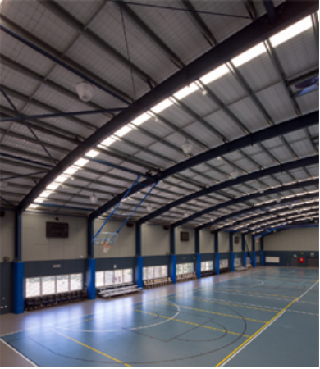 |  |  | Photo  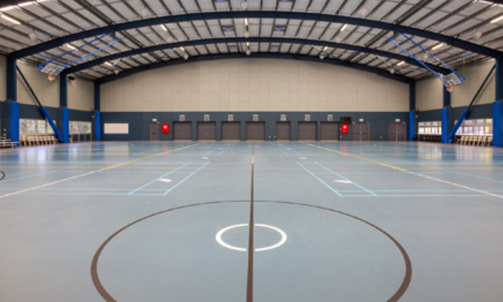
Size | m x m |  | Size | m x m
Other Facilities and notes
3 Full Size Futsal courts

