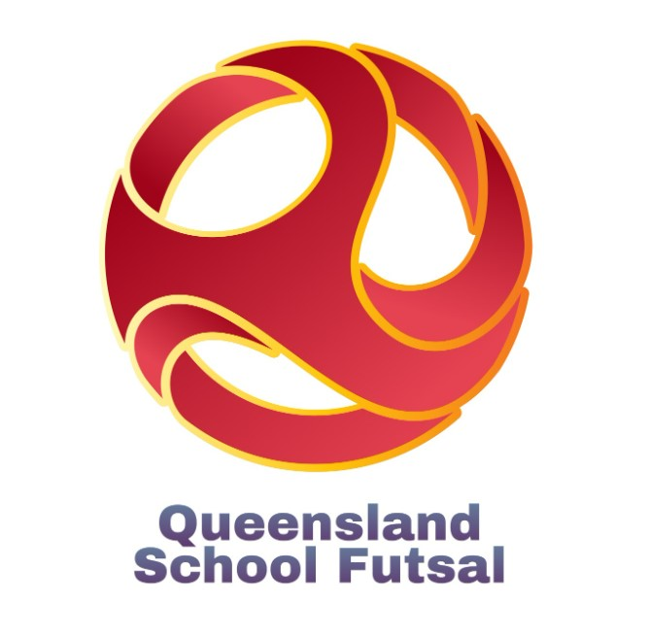

Code of Conduct

The code of conduct applies to all staff, volunteers, members, and participants who are involved or engaged with any Queensland School Futsal competition. The QSF Code of Conduct Policy is intended to provide guidance in addition to but not replace any applicable state or federal laws. At QSF, we observe high standards of conduct, and we expect all those participating with us to help maintain such high standards and assist in creating a safe environment.

All athletes deserve to play futsal and develop their skills in a positive environment which fosters their love of the game.

Zero Tolerance — It is extremely important that players are able to participate in sports free from bullying, hazing, sexual misconduct or any form of emotional or physical abuse.

Any form of harassment; psychological abuse, physical abuse, sexual harassment (verbal or physical conduct of a sexual nature which is unwelcome, or where consent is coerced, manipulated or cannot be given) will not be tolerated. Harassment may be deliberate, unsolicited and coercive.

Harassment and abuse can be expressed in five forms which may occur in combination or in isolation. It may be in person or online and often result from an abuse of authority, meaning the improper use of a position of influence, power or authority by an individual against another person.

Consequences for violating the code of conduct committed by an individual or group will be decided by the QSF judiciary and result in suspension or disqualification from QSF competitions.

