
School | Redeemer Lutheran College
Address | 745 Rochedale Road, Rochedale Queensland 4123 | School Finish Time |  | 3:15pm
Phone | 3340 8888 | Transport |  | Bus
Name email Mobile
Coordinator | Emily Thompson | ethompson@redeemer.com.au |  | 0434066779
Coaches
16 Boys | Emily Thompson | ethompson@redeemer.com.au |  | 0434066779
16 Girls | Greg Urlich | urlich.greggy@gmail.com |  | 0447557745
14 Boys | Emily Thompson | ethompson@redeemer.com.au |  | 0434066779
14 Girls | Greg Urlich | urlich.greggy@gmail.com |  | 0447557745
Venue Details
Court 1 | Multi-purpose Centre
Address | 745 Rochedale Road, Rochedale Queensland 4123
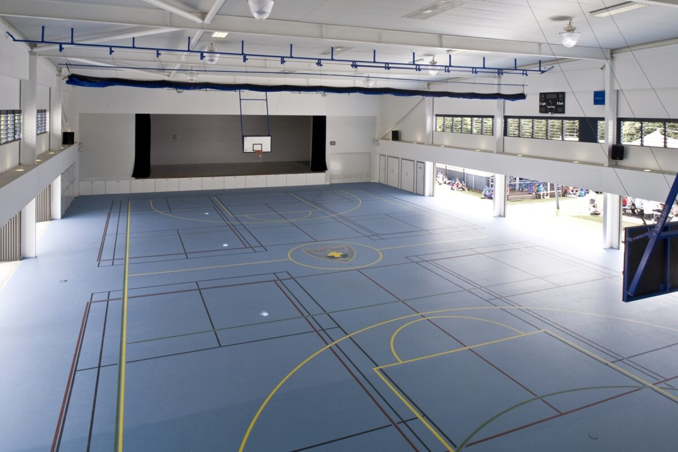
Photo

