Queensland School Sport

13 Yrs Boys Futsal CUP

Redbank Plains SHS (Champions) & Varsity College (Runners up)

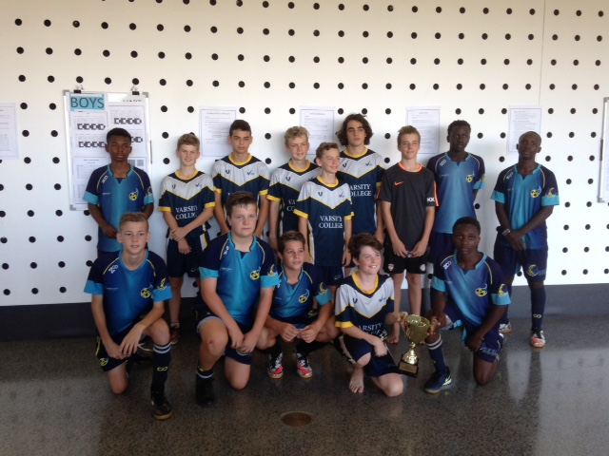

Results & Report

Coomera Indoor Sports Centre
Tuesday 22nd November 2016

Hosted by the South Coast Sport Region

Convenors Report

It is with great pleasure to report on the “inaugural” QSS 13 Years Invitational Futsal Cup and with agreeance from all involved declare that it was an outstanding success.

There were over one hundred schools from seven school sport regions that competed during the early stages of term 4 to decide the final 16 teams in both boys and girl’s categories that contested the finals at Coomera Indoor sports centre on Tuesday 22 November.

All team officials, venue staff, referees, players and supporters continually commented on the professional format of the competition, organizational quality, high standard of refereeing and the outstanding facilities and venue.

This carnival lays a strong foundation for the future recognition of “Futsal” in the Queensland School Sporting Calendar.

The staging of the carnival would not have been possible without the assistance and sponsorship from Trevor Edwards (Futsal Qld) and David Wiebe (referee coordinator) from FOOTBALL QUEENSLAND, Graham Ross & Mark Acaster from RED LION AGENCIES and Warren Kearns (Sports Medical officer ) from FIRST RESPONSE.
I would like to acknowledge their support and efforts.

It is hoped that this tournament has provided evidence for the present and developing support of “Futsal” in the majority of regions within the Queensland School sport structure and that in 2017, Regional Sports committees will agree to the support of the first “Invitational” State carnival on Saturday 18th and Sunday 19th of November at the newly developed Commonwealth games venue at Carrara Indoor Sports centre with the selection of district and / or regional 13 years boys and girls teams.

It is hoped to also continue with the 13 Yrs QSS Futsal Cup in the future years.

Alan Pradella

Carnival Convenor

“I've attended a lot of futsal tournaments over the years and this was easily the most organised one yet. The organisation beforehand was efficient and the day ran smoothly. The referees and student helpers were excellent also. The standard of competition would rival any AFA Champion of Champions tournament which is also a big plus! And the venue was outstanding. A great day - thanks for putting so much effort and energy into it. A side note - I feel sorry for anyone who has to pick a regional or state side in the future... so much talent.”

RESULTS

Pool A |  | Pool B |  | Pool C |  | Pool D
Marsden SHS  (Met East 1) |  | Varsity College  (South Coast 1) |  | Redbank Plains SHS  (Met West 1) |  | Chancellor College  (Sun Coast 1)
Lowood SHS  (Met West 2) |  | Aldridge SHS  (Wide Bay 3) |  | Toowoomba Grammar  (Darling Downs 1) |  | Harristown SHS  (Darling Downs 2)
St Andrews College  (South Coast 2) |  | Murrumba SC  (Met North 2) |  | Southern Cross Coll  (Sun Coast 2) |  | Albany Creek SHS  (Met North 1)
Urangan SHS  (Wide Bay 2) |  | Mansfield SHS  (Met East 3) |  | Calvary College  (South Coast 3) |  | Wellington PT SHS  (Met East 2)

Round 1
Pool | Time Court Court
A | 8.30 1 | Marsden 6 | V | Lowood SHS 2 | 2 | St Andrews Coll 8 | V | Urangan 4
B | 8.30 3 | Varsity Coll 14 | V | Aldridge SHS 1 | 4 | Murrumba SC 3 | V | Mansfield 3
C | 8.30 5 | Redbank Plains 1 | V | TWB Gram 4 | 6 | Southern Cross 1 | V | Calvary College 3
D | 8.30 7 | Chancellor 4 | V | Harristown 1 | 8 | Albany Creek 6 | V | Wellington Pt 1
Round 2
A | 9.50 1 | St Andrews 6 | V | Marsden 1 | 2 | Urangan 3 | V | Lowood SHS 2
B | 9.50 3 | Murrumba SC 4 | V | Varsity Coll 5 | 4 | Mansfield 10 | V | Aldridge SHS 1
C | 9.50 5 | Sthern Cross 2 | V | Redbank Plains 9 | 6 | Calvary College 3 | V | TWB Grammar 3
D | 9.50 7 | Albany Creek 1 | V | Chancellor 5 | 8 | Wellington Pt 2 | V | Harristown SHS 8
Round 3
A | 11.10 1 | Marsden 3 | V | Urangan 6 | 2 | Lowood SHS 3 | V | St Andrews Coll 6
B | 11.10 3 | Varsity College | V | Mansfield | 4 | Aldridge SHS 2 | V | Murrumba SC 16
C | 11.10 5 | Redbank Plains 9 | V | Calvary Coll 3 | 6 | TWB Grammar 13 | V | Southern Cross 2
D | 11.10 7 | Chancellor 11 | V | Wellington Pt 0 | 8 | Harristown SHS 3 | V | Albany Creek SHS 2

Elimination - Quarter Finals
 |  |  | Court 5 |  |  |  |  |  |  |  |  |  | Court 6
Bowl Q | 12.30 | 3 | C3 Calvary 8 |  |  | V |  | A4 Lowood 3 |  |  |  | 4 | C4 Sth Cross 1 |  |  | V |  | A3 Marsden 5
 |  |  | Court 1 |  |  |  |  |  |  |  |  |  | Court 2
Cup Q | 12.30 | 1 | A1 St And 1 |  |  | V |  | C2 Redbank 3 |  |  |  | 2 | C1 Toow’ba 7 |  |  | V |  | A2 Urangan 1
 |  |  | Court 3 |  |  |  |  |  |  |  |  |  | Court 4
Cup Q | 12.30 | 5 | B1 Varsity 3 |  |  | V |  | D2Har’town 1 |  |  |  | 6 | D1 Chanc’or 3 |  |  | V |  | B2 Murrumba 1
 |  |  | Court 7 |  |  |  |  |  |  |  |  |  | Court 8
Bowl Q | 12.30 | 7 | B3 Mansf’ld 6 |  |  | V |  | D4 Well Pt 1 |  |  |  | 8 | D3 Al Ck 23 |  |  | V |  | B4 Aldridge 3
Elimination - Semi Finals
 |  | Cup Semi Finals |  |  |  |  |  |  |  |  |  | Bowl Semi Finals
 | 1.50 | Redbank 3 |  |  | V |  | Toowomba 2 |  |  |  |  | Calvary 2 |  |  | V |  | Marsden 3
 |  | Court 4 |  |  |  |  |  |  |  |  |  | Court 8
 | 1.50 | Varsity 3 |  |  | V |  | Chancellor 2 |  |  |  |  | Mansfield 3 |  |  | V |  | Albany Creek 2
Grand Finals
Bowl | 3.45 | Court 1 |  | Mansfield 5 |  |  |  |  |  |  | v |  |  | Marsden 2
Cup | 4.00 | Court 3 |  | Redbank 7 |  |  |  |  |  |  | v |  |  | Varsity 3
4.45 Presentation of Trophies

Stage 1 - Finals Standings

Cup Finalists

Pos | Team | Pts | Gd | Gf | Rc | Yc
A1 | St Andrews | 9 | 12 | 20 | 0 | 0
B1 | Varsity | 9 | 15 | 23 | 0 | 0
C1 | Toowoomba Gr | 8 | 14 | 20 | 0 | 1
D1 | Chancellor Coll | 9 | 18 | 20 | 0 | 0
A2 | Urangan | 6 | 0 | 13 | 0 | 1
B2 | Murrumba | 5 | 13 | 23 | 0 | 0
C2 | Redbank Plains | 6 | 10 | 19 | 0 | 0
D2 | Harristown | 6 | 4 | 12 | 0 | 0

Bowl Finalists

Pos | Team | Pts | Gd | Gf | Rc | Yc
A3 | Marsden | 3 | -4 | 10 | 0 | 0
B3 | Mansfield | 5 | 8 | 16 | 0 | 0
C3 | Calvary | 5 | -4 | 9 | 0 | 0
D3 | Albany Creek | 3 | 0 | 9 | 0 | 0
A4 | Lowood | 0 | -8 | 7 | 0 | 0
B4 | Aldridge | 0 | -36 | 9 | 0 | 0
C4 | Southern Cross | 0 | -20 | 5 | 0 | 0
D4 | Wellington Point | 0 | -22 | 3 | 0 | 0
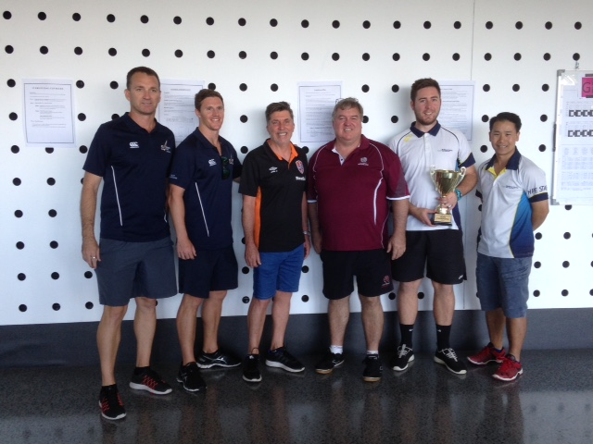

From Left to Right - Murray Goodwin, Jamie Irwin (Varsity College) , Alan Pradella (Convenor) , Trevor Edwards (FQ) Mitch Davis, Ngoc Bui (RPSHS)
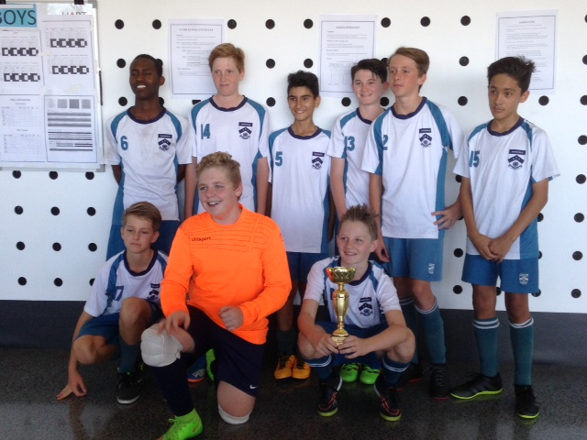

Bowl Champions – Mansfield SHS

Competing Teams

POOL A

Marsden SHS | Lowood SHS
Maroon / Black Green / White

1 | Paul Raphael |  | 3 | Jace Martyn
2 | Mo Safdari |  | 41 | Lachlyn Whitmore
3 | Ryan Rivett |  | 1 | Lachlan Miller
4 | Rydell Griffith |  | 4 | Matthew Leschke
5 | Peter Filips |  | 23 | Raiden Shannon
6 | Ryan Kov |  | 31 | Levi Thornton
7 | Jacek Wlazlo-Walewski
8 | Hussain Mohammadi
9 | Lynton Riches

Coach | Lachlan Leong |  | Coach | Jacob Veraart
Managr |  |  | Managr

St Andrews College | Urangan SHS
Navy Blue/White / Red Red / Black

18 | Lucas Nash |  | 18 | Ollie Shuttleworth
7 | Matthew Gabriel |  | 5 | Jake Sams
1 | Ethan Radley |  | 19 | Harrisen Douma
36 | Stephen Lockhart |  | 12 | Liam Brindley
21 | Jayden Sonter |  | 13 | Jake Kirkwood
24 | Mackenzie Glover |  | 3 | Kurtis Eason
32 | Darby Scott |  | 1 | Hunter Dunn
12 | Flynn Charters |  | 9 | Max Goldman
42 | Jayden Racette |  | 4 | Oakley Smith

Coach | Paul McGilveray |  | Coach | Sarah Walker
Managr | Mark Hibbs |  | Manager

Competing Teams

POOL B

Varsity College | Aldridge SHS
Blue / White / Yellow Purple / Navy

1 | Kade Kennaway |  | 21 | Lachlan Porter
7 | Charles Coppin |  | 22 | Masan Shaw
8 | Christian Vulinavich |  | 23 | Brandon Carrubias
9 | Levi Russell |  | 32 | Quin McKeogh
10 | Josh Gardiner |  | 33 | Tyson Anderson
11 | Hunter Skalij |  | 34 | Ethan Regden
12 | Matthew Geyer |  | 25 | Hassan Dolly
15
16

Coach | Murray Goodwin |  | Coach | Wayne Mooney
Manag |  |  | Manag'r

Murrumba SC | Mansfield SHS
Maroon / Gold Teal / White / Black

1 | Joshua Brown |  | 2 | Joseph Greenwood
11 | Aidan Collins |  | 15 | Brayden Darwen
4 | Joel Carpenter |  | 6 | Hanard Abdirisaq
5 | Joshua Boyce |  | 16 | Max Robertson
6 | Finn Robertson |  | 13 | Connor Robertson
7 | Ashton Ward |  | 17 | Oscar Barwick
8 | Brayden Winlaw |  | 14 | Nathan Docherty
9 | Jayden Lynch |  | 5 | Stelios Melli
 |  |  | 1 | Luke Axford

Coach | Alistair Watt |  | Coach | Reece Goudge
Manager |  |  | Manager

Competing Teams

POOL C

Redbank Plains SHS | Toowoomba Grammar
Sky Blue / Royal Blue Blue / Blue

81 | Jordan Pritchard |  | 5 | Jarrah McNicol
105 | David Ishimwe |  | 1 | Marcus Johnston
114 | Patient Lukonga |  | 3 | Liam Foley
130 | Shafi Amza |  | 15 | Ben Moore
133 | Almin Djemajlovic |  | 7 | Jake Eiser
164 | Ngong Ngong |  | 9 | Joe Wood
185 | Kai Jones |  | 7 | Callum McCarthy
 |  |  | 8 | Kavinda Perera
 |  |  | 12 | Dylan Proctor
 |  |  | 11 | Alex Kiers

Coach | Mitchell Davis |  | Coach | Peter Broadfoot
Managr |  |  | Manager

Southern Cross College | Calvary College
Red/ White White / Purple

7 | Alex Witte |  | 1 | Jack Morris
15 | Ethan Turner |  | 3 | Samuel Baker
8 | Brandan McCabe |  | 3 | Mackinley Long
6 | George Bates |  | 11 | Jacob Biddle
3 | Mark Morris |  | 5 | Seth Matthews
1 | Ben Wallace |  | 6 | Jeremiah Waters-Whyte
 |  |  | 7 | Nathan Salt
 |  |  | 8 | Daniel McEwan
 |  |  | 9 | William Glen
 |  |  | 10 | Noah Atkins

Coach | Sean Morrison |  | Coach | James Colefax
Manager |  |  | Manager | Ben Schmidt

Competing Teams

POOL D

Chancellor College | Harristown SHS
Blue / White Blue / Blue

21 | Kyle Barnes |  | 5 | Josh Mackay
22 | Mason Barry |  | 9 | Memphis Smith
23 | Matthias Collins |  | 19 | Frank Bagalwa
25 | Connor Evans |  | 20 | Hunter Purcell
1 | Bae Galloop |  | 24 | Ky Richardson
127 | Kane Gibbs |  | 21 | Levi Cuskelly
96 | Lewis Gordan |  | 30 | Gabriel Dacosta
1 | Josh Morwood |  | 29 | Max Bonnell
40 | Kurt Cochteloo

Coach | Amanda Nasternak |  | Coach | Chris Wilkes
Manag’r | Jeremey Stewart |  | Manager

Albany Creek SHS | Wellington Point SHS
Yellow / White Teal / Black

1 | Jack Colmer |  | 1 | Gian Rallah
14 | Jarryd Allen |  | 2 | Natthepoom Lertsin’trakul
21 | Riley Shea |  | 3 | Mitch Adams
18 | Shannon Hundley |  | 4 | Joshua Alcorn
6 | Jordan Lettreri-Perreria |  | 5 | Anton Rallah
20 | Nicholas Petersen |  | 6 | William Gibson
15 | Tyler Kennedy |  | 7 | Jay Watson
34 | Freddie Covacic |  | 8 | Jai Brady
11 | Riley Ferguson |  | 9
 |  |  | 10

Coach | Paul Freeman |  | Coach | Andrew Diete
Manager |  |  | Manager

Undoubtedly the best Futsal carnival I have attended in 20 years plus of involvement with Futsal. The venue was second to none, (superb) with change rooms, warm up areas, electronic timing/scoreboards for each of the 8 courts, panoramic viewing area, first aid, alfresco dining, well ventilated/cool and a safe venue etc. My students thoroughly enjoyed the day and are keen to come back next year. The competition was well organized and all teams had the same breaks between matches, so no teams were advantaged or disadvantaged. Everything ran like clockwork. Happy to be involved in getting Futsal as a QSS sport…..Steve Broderick (St Ursula’s College, Darling Downs)

I would like to thank you for all your hard work and organisation of the QSS 13 years cup. It was a great day, well organised and very professionally run. I would also like to thank Trevor Edwards and FQ for the progression and involvement with QSS. Both the Chancellor boys and girls teams thoroughly enjoyed the tournament and can’t wait for 2017. Thanks again for all your efforts yesterday ……………………………..Jeremy Stewart (Chancellor State College , Sunshine Coast)

Thank you so very much for running a great tournament yesterday. It was extremely refreshing to turn up at an amazing venue. The standard of refereeing throughout the day was very high and it was great to have two ref’s for the final series. The entire event ran extremely well and we cannot wait for next years!!!!Again, thank you so very much for hosting us and running a very professional event………………………………………………………..Jamie Irwin (Varsity College, South Coast)

The tournament was fantastic! The organisation prior and during the day was outstanding. It was so great to have team sheets already printed . The standard of referees was fantastic. As a regional school it was such a great opportunity to play at such a great venue against quality teams. It was awesome to see Katrina Gorry there and the partnership with Football Qld. The concept of making it a school sport would be highly beneficial to all students across our state. Thank you to you and your team for such a great day………………………………….Sarah Walker (Urangan SHS, Wide Bay )

I would like to take this opportunity to thank you for your time and organisation of this carnival. It was well organised and professionally delivered and the venue was second to none. Communication was clear and provided early on and on the day everyone was welcoming and very helpful. The Glennie girls thoroughly enjoyed the event and it goes without saying that I would be more than happy to assist with whatever is required on a regional level. Always great to see Trevor Edwards on board and I am so happy we are making in roads to link with FQ. Susan Watts (Glennie School, DD)

I've attended a number of futsal and Football tournaments over a few years and this one was a well organised and staffed . From the initial emails to the communication on the day it all worked . Great to see the high standard of referees, student helpers, admin and competition. Looking forward to next year-……………………………………………………Wayne Mooney (Aldridge SHS, Wide Bay)

Great day mate, it’s been a while since I’ve been to a carnival without any hiccups, so well done for putting on a good show. Venue was world class. Referees were great too and I don’t get to say that too often! Cheers. …………………………………….Nathan Knox (Aspley SHS, Metropolitan North)

  `

