Queensland School Sport


2018 Futsal - Metropolitan Finals - Report

13 Years Boys and Girls

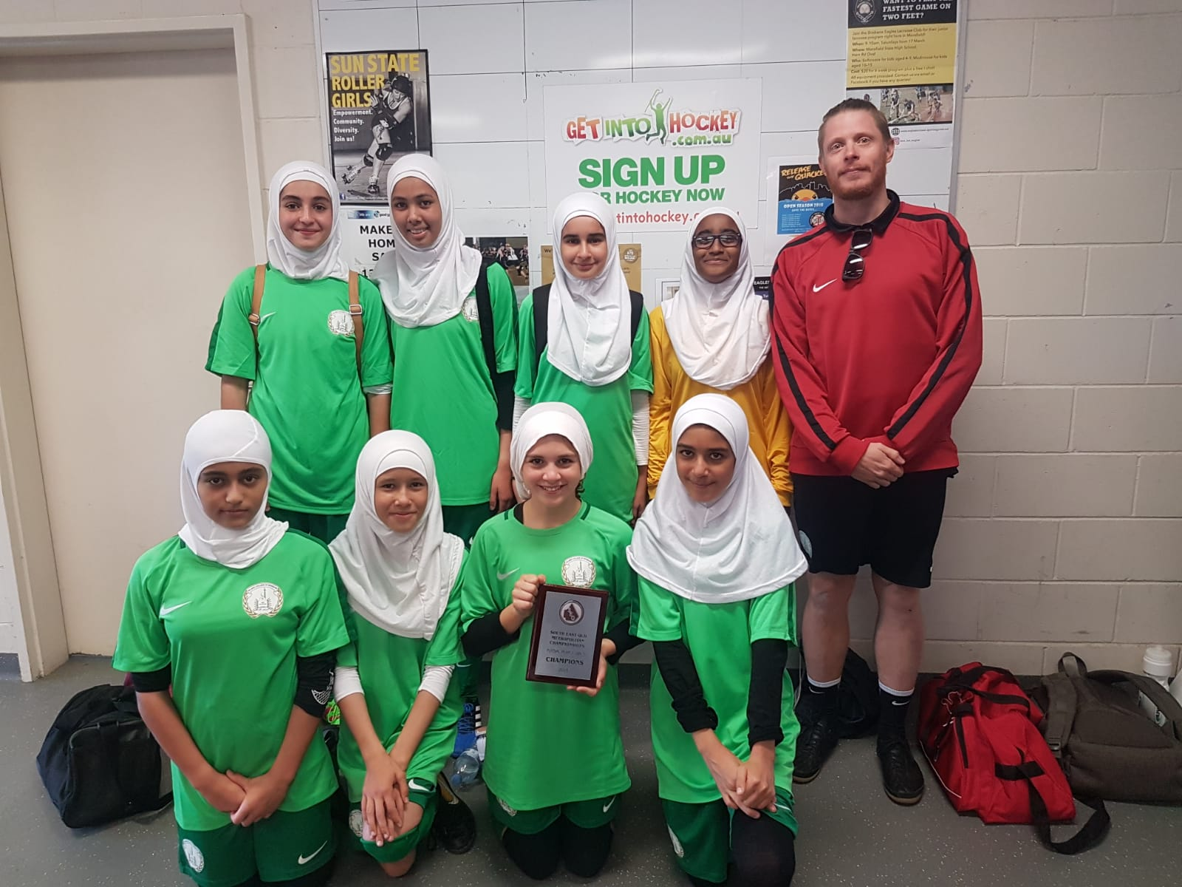
Girls Champions – Brisbane Islamic College

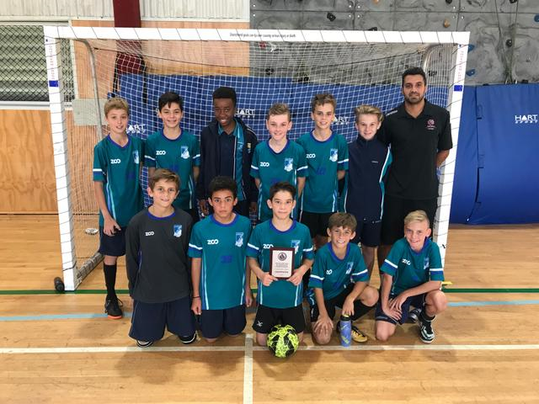
Boys Champions – Kings College

Results

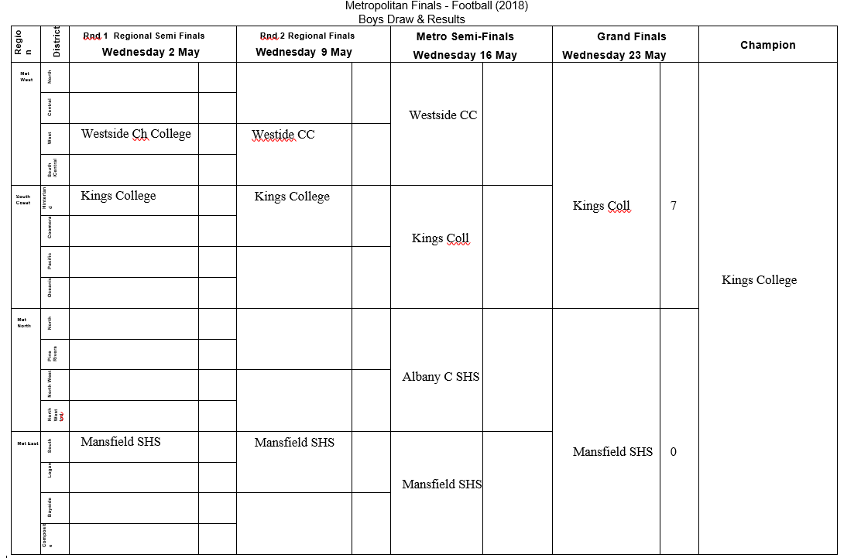

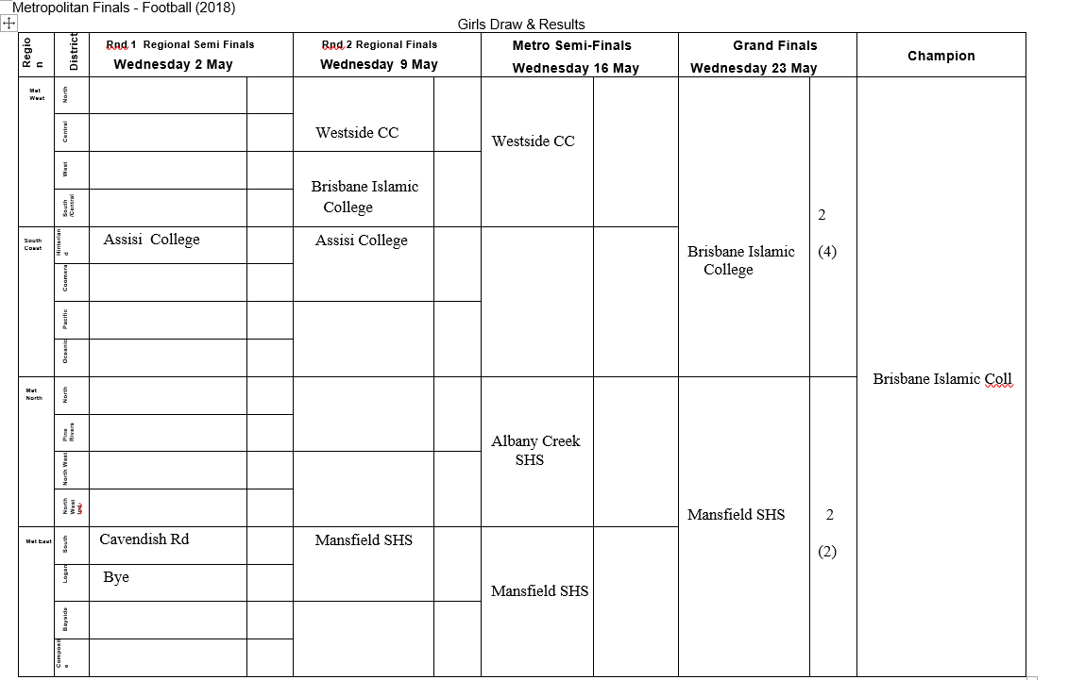

METROPOLITAN FINALS - FUTSAL
RULES AND PROCEDURES
2018

The inaugural Metropolitan Finals for “Futsal” will be played for Year 7 Boys and Girls teams in Term 2, 2018.

The “Champion” school teams from all districts with the Metropolitan North, Metropolitan East, Metropolitan West and South Coast Regions in Term 1 are invited to enter the 2018 Finals.

District “Champion” teams may be decided from

- District competitions that are played regularly in Term 1 or

- Gala Day carnivals organised by district convenors in Districts where there is no regular Term 1 weekly competition or

- Playoff matches that may be organised by nominating schools within the district through district convenors (see list below)

The, dates, times and venues for all Playoffs are set out below.
Date | Final | Venue | Time | Contact
Term 2- Week 2 | All district champions to be decided
Rd 1- Tues 31 April | Regional Semi Finals | tba | tba | Regional Con
Rd 2- Tues 8 May | Regional Finals | tba |  | Regional Con
Rd 3 - Tues 15 May | Metro Semi Finals | Eagles Complex |  | Alan Pradella
Rd 4 - Tues 22 May | Metro Grand Finals | Eagles Complex |  | Alan Pradella

VENUES

Rounds 1 & 2 this year schools can arrange mutually central venues between themselves and their
Opponents.
Referees can be arranged through David Weibe and Trevor Edwards at Futsal Qld (trevoredwards
Facilities must be of a suitable standard and as per the rules, nets,etc.,
If schools cannot agree the Metropolitan Finals Football Convenor will decide.

We will use set central venues for all Semi-Final and Final games.

REFEREES

REFEREES WILL NOT BE PROVIDED FOR THE ROUND 1 & 2 GAMES.

Schools are to make their own arrangements regarding referees for these games. A badged qualified referee in uniform must be used. Each school should arrange at least one qualified referee for each game. The schools are responsible for paying any referees used in Rounds 1 & 2, this must be finalised on the day of the game.
Schools should not use parents or relatives of the team to officiate.
If you have difficulty in arranging a referee for quarter finals, please contact Trevor Edwards at Futsal Brisbane – Phone 3347 0047. Please give Trevor and David as much time as possible to arrange referees.

REFEREES WILL BE APPOINTED FOR THE SEMI FINALS & GRAND FINALS. LEVIES

To cover the costs of medallions, ground hire, referees, etc; a levy will be charged to each school at the completion of the competition. All efforts have been made to minimise the levy and will vary based on how far your team progresses through the finals series and will range from $35 - $90 per team. All schools will be levied after the grand finals by Mansfield State High School.

RULES

All matches will be played according to the current FIFA rules except as below. PLAYING SCHEDULE - ALL ROUNDS

To ensure each round runs on time, it is the responsibility of each school to abide by the following time schedule, sufficient time should be allowed for games to play extra time and complete a penalty shootout.

DURATION OF GAME

Year 7 - 2 x 20 min. halves. 5 min half time.

In the event of a draw at the end of normal time, 1 x 10 minute extra time will be played using the Golden Goal rule. If the scores are still level, then the result will be determined by penalties as per
F.I.F.A. rules.
It is the responsibility of coaches to make referees aware of the above times.

TEAMS

Teams are to have a maximum of 10 squad players.

SUBSTITUTIONS

A maximum of five (5) substitutes are allowed with unlimited interchange. ALL substitutionss / interchanges must take place at the half way line at any time except if a GK change is needed then that must take place during a break in play and at the referee’s discretion.

Coaches need to make the referees aware of this variation to the rules of the game.

ATTIRE

All players must wear shin pads as per FIFA Laws of the Game .

All players must wear numbered shirts (as per the Laws of the Game). Players names and numbers must match the team sheet in case of cautions, send offs and goal scorers or unfortunately disputes.

TEAM SHEETS

Please complete the attached team sheet and email it to the convenor before Round 1 games. Once the team sheet is submitted it cannot be changed without prior notifying the convenor so opposing teams can be notified of the changes. Please be aware that Maximum Team Size is 10 Players. Age qualifications for these finals are as follows:

YEAR 7: Year 7 and 13 yrs (all players must be in Year 7 and cannot turn 14 yrs in the year of competition).

Team Sheets must be produced if requested by the referee, convenor or opposition and players must be able to be identified if requested, e.g. produce their Student Identification at the ground. This is to avoid disputes at a later date about a player’s eligibility. This copy is to be emailed with the score sheet by the winning team.

RESULTS

To record the results each school should print and take a copy of the score sheet to ensure the game details are accurately recorded.

Both schools must email the result of the game to Alan Pradella aprad2@eq.edu.au by midday the following day.

The winning team must take responsibility for emailing the official score sheet to the convenor by the next day. This should be signed by both coaches and the referee, this is most important as the score sheet may be used for disputes or information affecting future games.

In case of score discrepancy or protest, please follow the rules for disputes as below.

DISPUTES AND QUERIES

Please keep in mind that disputes relating to referee decisions should be resolved at the event, keeping in mind that once the game commences all referee decisions are to be accepted. Disputes about who referees should be resolved before kick-off.

All disputes must be submitted to the convenor in writing within 24 hours of the game, so that a speedy resolution is possible.

All score sheets signed by the referee cannot be changed, so any score sheet details / disputes must be discussed prior to signing.

If you as a coach are unhappy about the details on the score sheet, do not sign it and put your concerns in writing. In the majority of these cases, the referee will be contacted to provide information in processing the dispute.

Disputes about the conduct of players, coaches, officials, parents/supporters etc are to be directed to the Sports Coordinator of the opposing school the day following the match. It is only the school of the person involved who can take disciplinary action in these matters.

Regional and District Convenors

RE

Region | District | Convenor | School
Met East | South | Alan Pradella | Mansfield | aprad2@eq.edu.au
 | Bayside | Huw Fitzpatrick | Alexandra Hills | Hfitz35@eq.edu.au
 | Logan | Trudi Bartlett | Marsden | tbart115@eq.edu.au
 | Composite | Scott Purse | BSHS | spurs9@eq.edu.au
Met West | South |  | Park Ridge
 | East | Craig Burchell | Bris Adv Coll | cburchell@icb.qld.edu.au
 | North |  | Kenmore
 | Central | Mitch Davis | Redbank Plains | Mdavi554@eq.edu.au
 | West | Scott McDonald | Ipswich | smcdo328@eq.edu.au
Met North | North West | Paul Freeman | Albany Creek | pfree5@eq.edu.au
 | North West Ind | Michael Out | Padua | mout@padua.qld.edu.au
 | Central | Nathan Knox | Aspley | nknox2@eq.edu.au
 | Pine Rivers | Shayne Kriel | Genisis | s.kriel@genesis.qld.edu.au
South Coast | Hinterland | Paul McKarzel | Assisi Coll | paulmckarzel@hotmail.com
 | Broadwater | Matthew Davies | Beaudesert | mdavi616@eq.edu.au
 | Pacific Rim | James Colefax | Calvary Coll | james.colefax@calvarycc.qld.edu.au
 | Oceanic | Teonie Rushton | Robina | trush27@eq.edu.au

(Regional convenor highlighted)

METROPOLITAN FINALS CONVENOR CONTACT DETAILS
Alan Pradella
Mansfield SHS
Phone: 3824 9222 Phone: 3203 0066
Mobile: 0424738209
Email: aprad2@eq.edu.au

Reviews and Comments
Thanks again for a great match and organising the finals. I sincerely hope this is the start of something big for futsal in Queensland schools and I am more than happy to be involved.
Kind Regards,
Craig Burchell
HPE Teacher and Futsal Coordinator
Islamic College Of Brisbane
Thanks again Alan. Really appreciate all your efforts in putting this together.
Stuart Welsh

Summary

- Overall a successful carnival

- Due to the fact it is the first year of the Metro finals, hopefully with advertising more districts in all regions will become aware of the finals and endeavor to run Term 1 competitions to encourage higher level competition within regions.

- Tremendous support from Football Queensland (Medals, balls, referees) and Gold Coast trophies and hope that will continue

- All Referees will be fully experienced and future trainees students can be utilized

- Event timing fits in well with all other Metro Finals scheduling, but “Naplan” testing may have to be considered next year.

`

