
School |  | St James College
Address |  | 201 Boundary St, Spring Hill, 4000 | School Finish Time |  |  | 3pm
Phone |  | 3230 8600 | Transport |  |  | School Bus
Name email Mobile
Coordinator |  | James Anderson | janderson@stjamescollege.qld.edu.au |  |  | 0412 979904
Coaches
16 Boys |  | Callan Wiseman | cwiseman@stjamescollege.qld.edu.au |  |  | 0405 198079
16 Girls |  | Jeremy Seng | jseng@stjamescollege.qld.edu.au |  |  | 0488 411934
14 Boys |  | James Anderson | janderson@stjamescollege.qld.edu.au |  |  | 0412 979904
14 Girls |  | James Anderson | janderson@stjamescollege.qld.edu.au |  |  | 0412 979904
Venue Details
Court 1 |  |  | Court 2 |  | NO 2nd Court
Address |  | School Hall as above
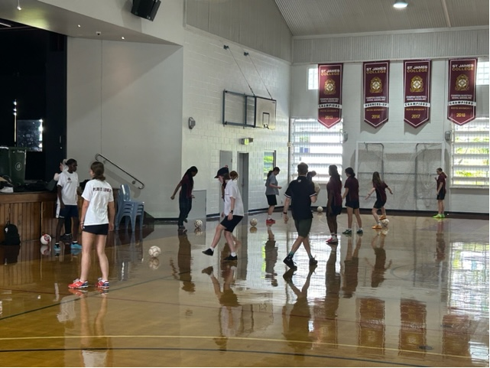 |  |  | Photo
Size | 30 m x 15 m |  | Size | m x m
Other Facilities and notes
List
We only have 1 court which means that games will need to be played back to back. Contact James Anderson prior to the game to arrange which team will play first.
Bus and car parking is available around the back of the school, enter via Hartley St and turn onto Gloucester St and enter the school through the back gate. Park the bus / cars on the lower yard.
Home Strip – Maroon
Away Strip - White

