
School |  | HILLCREST CHRISTIAN COLLEGE
Address |  | 21 BRIDGMAN DR, REEDY CREEK, QLD 4227 | School Finish Time |  |  | 3PM
Phone |  | 07 55934226 | Transport |  |  | BUS
Name email Mobile
Coordinator |  | RENAN FENERICH | Email: RDEOLIVEIRAFENERICH@HILLCREST.QLD.EDU.AU |  |  | 0488288813
Coaches
16 Boys |  |  | RENAN FENERICH
16 Girls |  |  | RENAN FENERICH
14 Boys |  |  | RENAN FENERICH
14 Girls |  |  | RENAN FENERICH
Venue Details
Court 1 |  | MPH Court | Court 2 |  | MLC Courts
Address
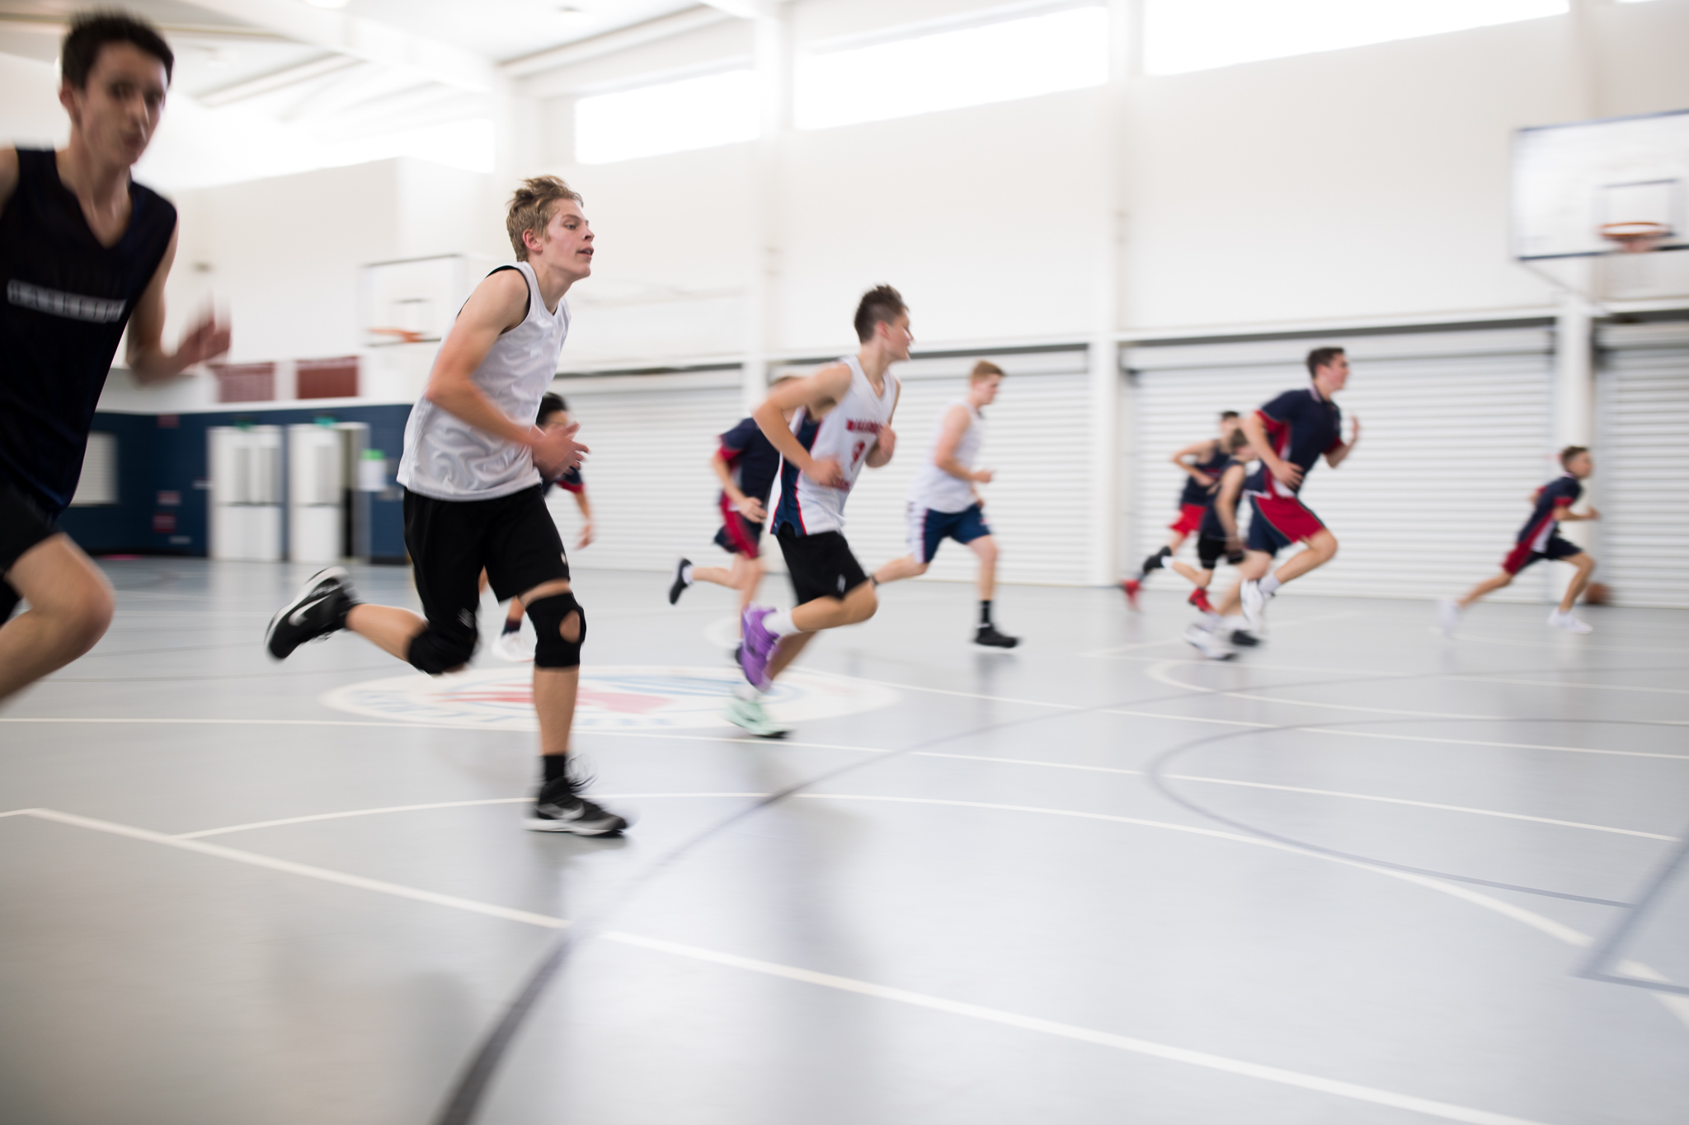 |  |  | 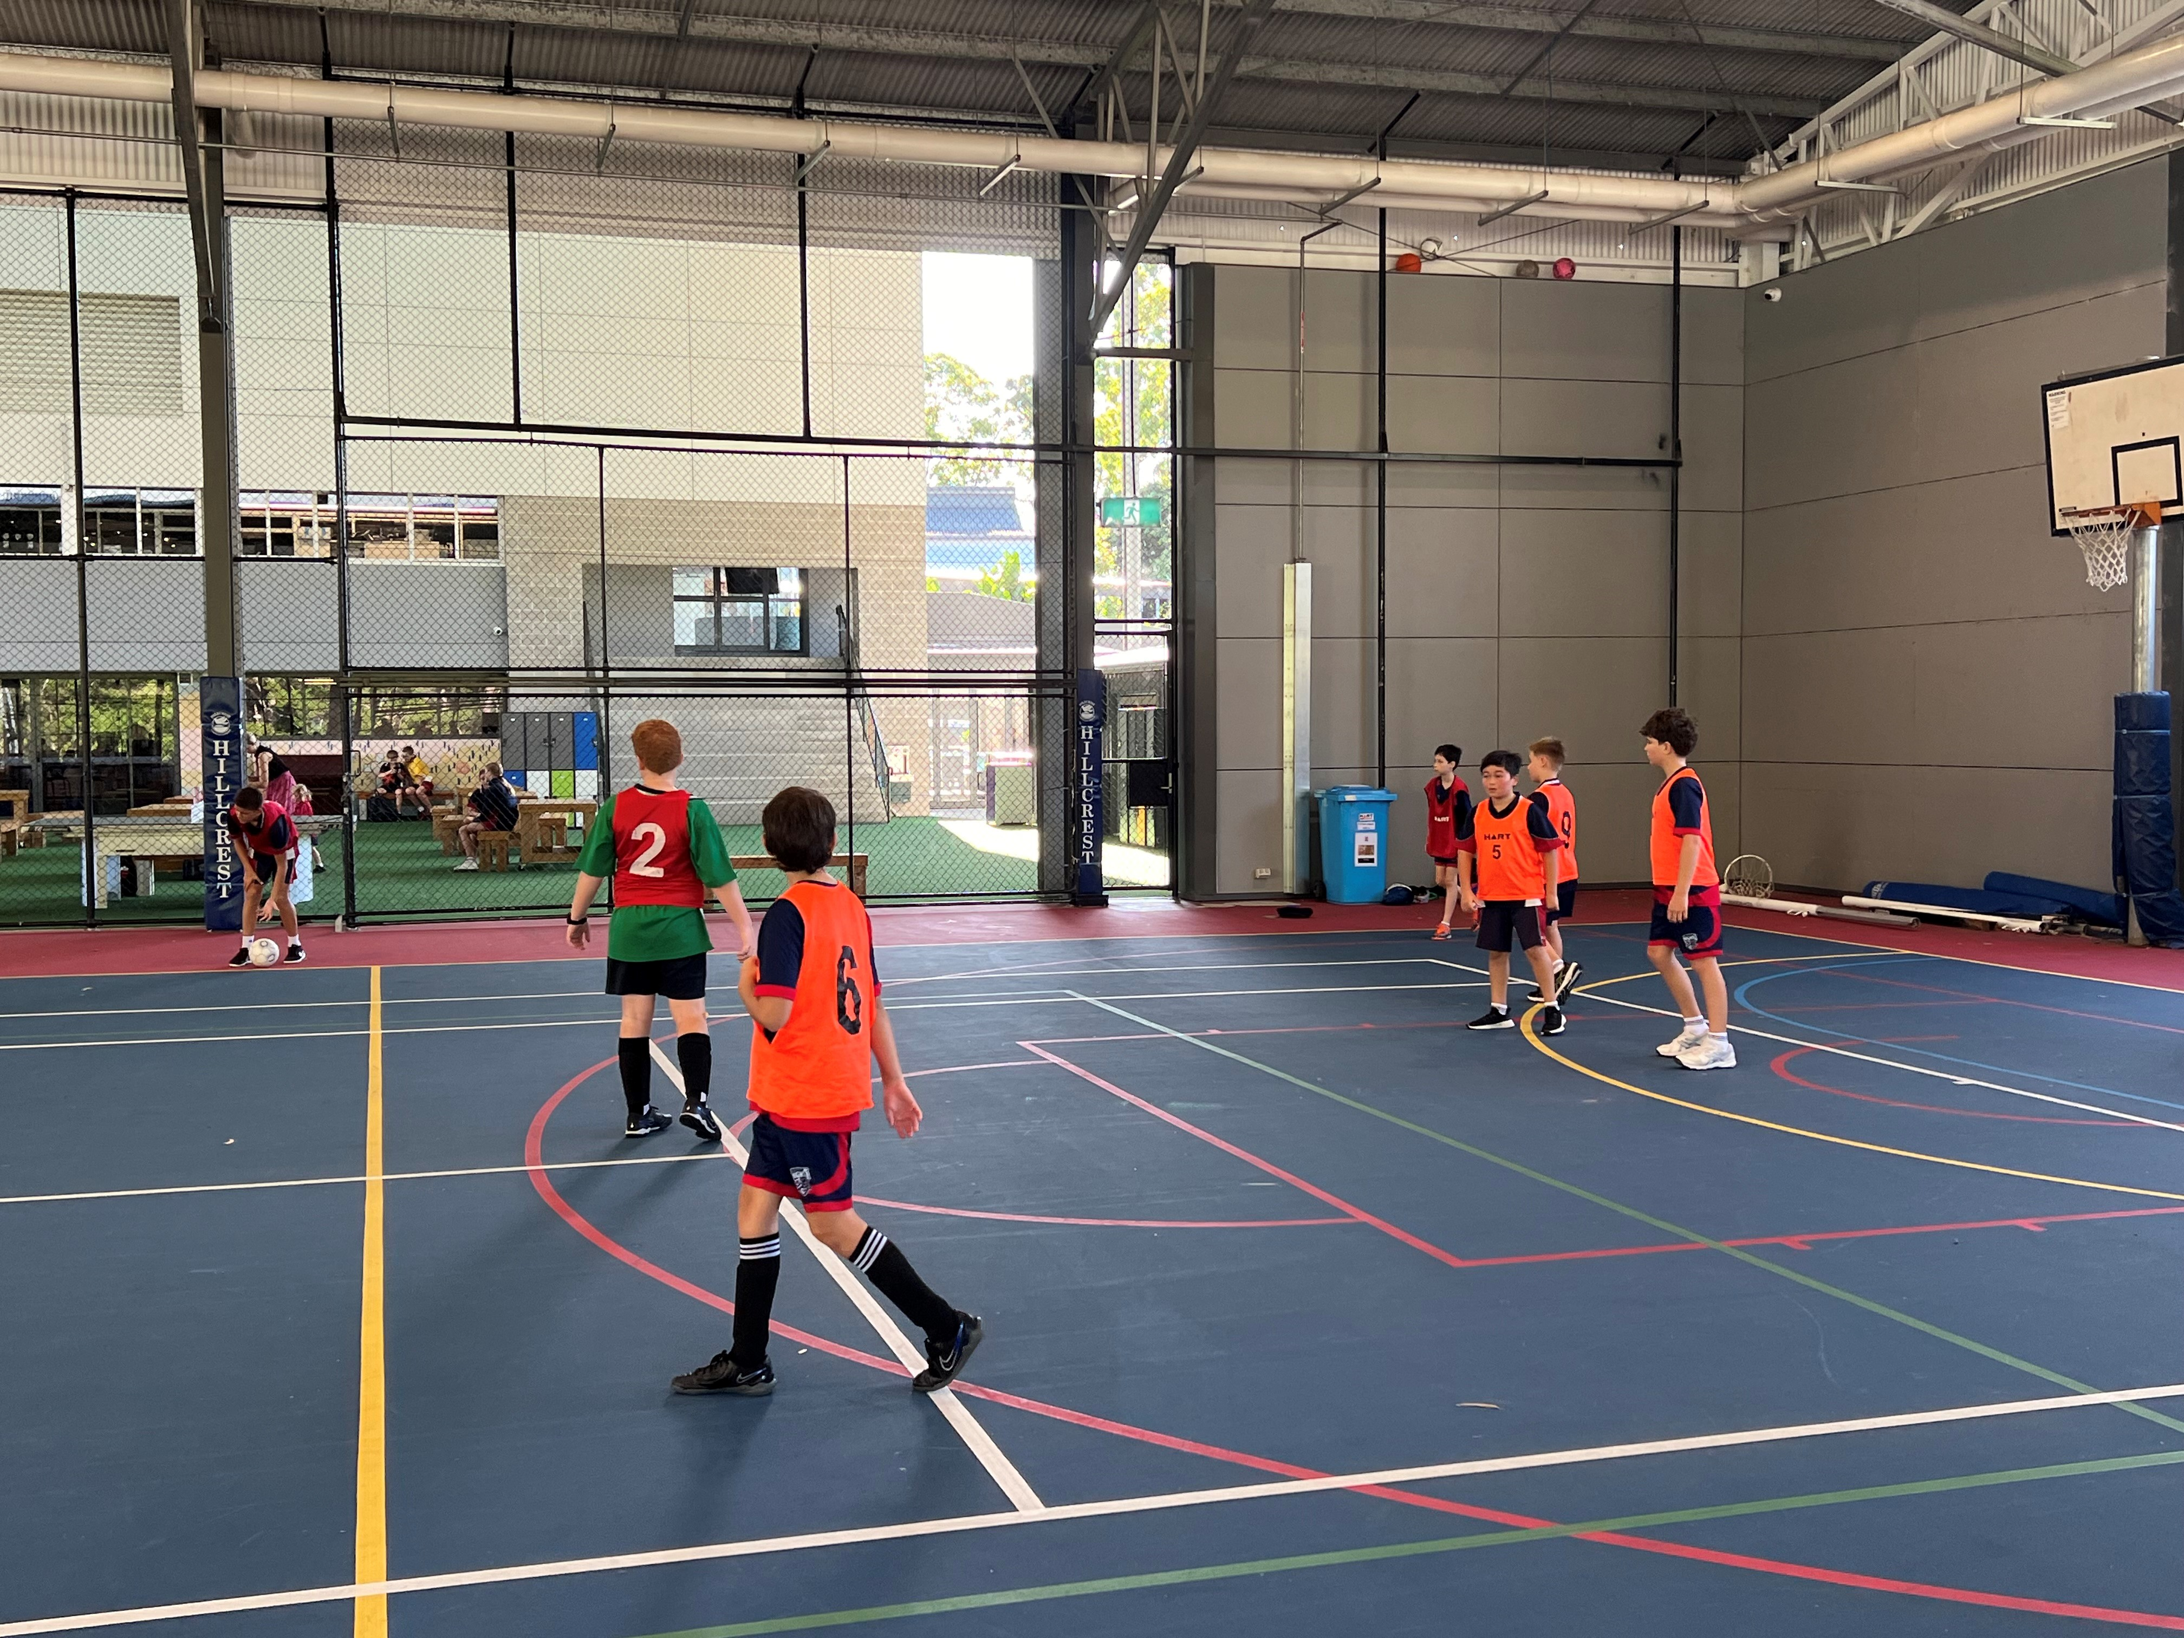
Size | Regular size court |  | Size | Regular size court
Other Facilities and notes
Changing rooms, toilets, bubblers, etc…

