**2025**

**ACADEMY ONE FOOTBALL TOURS**

**QSF CUP**

**

**Information**

**Table of Contents**

|  |  |  |
| --- | --- | --- |
| **Competition details** | **………………………………………..** | **3** |
| **Age Groups, Formats, Nominations, Draws** | | |
| **Divisional Dates** |  |  |
| **Peninsula/Northern** | **…………………………………………** | **8** |
| **Wide Bay/Capricornia** | **………………………………………..** | **9** |
| **Southeast Queensland** | **………………………………………..** | **10** |
| **Match Rules** | **………………………………………..** | **11** |
| **Costs/ Referees** | **………………………………………..** | **14** |
| **Results** | **………………………………………..** | **15** |
| **Documents** | **………………………………………..** | **16** |
| **Team Lists** | **………………………………………..** | **17** |
| **Squad Lists** | **……………………………………….** | **18** |
| **Communication** | **……………………………………….** | **19** |
| **Staff** | **……………………………………….** | **20** |
| **Social media** | **……………………………………….** | **21** |
| **Sponsors** | **……………………………………….** | **22** |
| **2025 QSF Calendar** | **……………………………………….** | **23** |
| **Australian Futsal Cup** | **……………………………………….** | **24** |
|  |  |  |
|  |  |  |

**Competition Details**

**The QSF Cup is a Queensland school 12 years (primary school) and 14 Years boys and girls Futsal tournament organized by the QSF committee open to all schools in Queensland.**

**The competition run 3 Cup competitions within the state’s School Sport Regions –**

**Peninsula / Northern**

**Wide Bay / Capricornia**

**Southeast Queensland**

**The champion schools from each of the 3 Cup competitions will then qualify and be invited to participate in the “Australian Schools Cup” in term 4 at the Gold Coast which will incorporate 12 other interstate and New Zealand champions school teams.**

**The QSF Cup provides the opportunity for all schools to participate and compete against other schools within their district, region, state and nation.**

**Although the QSF Cup is open to all schools in the state, due to time and venue constraints, a restricted number teams nominating in each division can be accepted. (Schools may be asked to play qualifying matches be placed on waiting lists.**

**AGE GROUPS: Boys and Girls**

**12 Years (Students must be in Year 6 or below and cannot turn 13 or older in 2025) Girls** may play in the Boys division only if the school does not have a representative Girls team

**14 Years (Students cannot turn 15 or older in 2025)**

**Tournament Formats**

**The Regional QSF Cups may be restricted to a 1 Day tournament due to travel costs, while the SEQ QSF Cup will be a 2 Day tournament.**

**2 Day QSF Cup Format**

**Once nominations are finalized, the 16 schools will be randomly placed in Pools of 3 or 4 teams.**

**On Day 1** **each team in their respective pools will play each other once. At the end of Day 1 the first and second placed teams from the 4 pools will then compete in the Day 2 “Cup” competition. Teams finishing third and fourth in the Day 1 Pools will compete in the Day 2 "Shield" competition.**

**On Day 2, the 8 teams in the “Cup” competition will play cross over quarter finals. Winners will proceed to the Cup semifinals and losers will play consolation playoffs. Semi Final winners will proceed to the Cup Grand Final and losers will play in the playoff for 3rd and 4th positions. All teams will play 3 matches on Day 2.**

**The teams that finish third and fourth in their respective Day 1 Pools will play off for the “QSF -Shield’ competition on Day 2 in the same format as the Cup competition.**

**1 Day QSF Cup Format**

**The format of the draw will be determined by the number of nominations and teams.**

1. **12 team competition (12 Boys teams or 12 Girls teams)**

**- the 12 teams will be randomly placed in 3 Pools of 4**

**Each team in their respective pools will play each other once.**

**At the end of the Rounds the teams will be ranked from highest ranked first to 3rd highest ranked first position, then highest ranked 2nd position etc., and highest ranked second from the 4 pools will then play Cup semifinals (random draw), Cup Finals and 3rd/4th playoff.**

**Other Teams finishing in second positions and highest ranked third placed teams after the Pool rounds matches will compete in the "Shield" competition.**

**4th Placed teams will play for positional playoff positions.**

**(b)12 team competition (6 Boys teams & 6 Girls teams)**

**- the 6 teams will be randomly placed in 2 Pools of 3**

**Each team in their respective pools will play each other once with a crossover pool match.**

**At the end of the Rounds the Team ranked 1st in Pool A will play the team ranked 2nd in Pool B, and the tyeam ranked first in Pool B will play the team ranked 2nd in Pool A. Teams ranked 3rd in both pools will play the Shield Final.**

**The semifinals winners will play the Cup Grand Final and loser will play for bronze medals in the 3rd/4th playoff.**

**NOMINATIONS**

**Nomination forms are available on the QSF website and will close at the end of Week 10, Term 4, 2024.**

**All conferences will have maximum of 16 Boys and 16 Girls teams, so schools nominating after the competition limits have been filled, will be placed on "Reserve" lists.**

**Competition Invoices will be sent in Week 1, Term 1, 2025 and nominations will then be finalised after nomination fees have been paid.**

**DRAWS**

**The Draws for all 3 Divisional QSF Cup Divisional Cups will be made after nominations have been finalised, and available in Week 1, Term 1, 2025 on the QSF Website.**

**Peninsula / Northern QSF Cup Details  
VENUE: Redlynch Indoor Sports Centre – 3 Chelsea Lane Redlynch, Cairns**

**FORMAT:**

**The Peninsula / Northern QSF Cup will be a 1 day - 12 - team tournament comprised of 3 Pools of 4 with all teams playing 3 round matches followed by Semifinals, Finals and Playoff matches.**

**Boys and girl’s rounds will be played together on the day.**

**Teams finishing top of their pools, and the best placed 2nd will qualify for the Cup playoffs and teams finishing second and 2 best placed thirds qualify for the Shield playoffs.**

**All other Teams will play positional playoffs**

**DATES:**

|  |  |  |  |
| --- | --- | --- | --- |
| **14 Years** |  |  |  |
| **Boys** | **QSF Cup** | **Thursday** | **19th June** |
| **Girls** | **QSF Cup** | **Thursday** | **19th June** |
|  |  |  |  |
| **12 Years** |  |  |  |
| **Boys** | **QSF Cup** | **Friday** | **20th June** |
| **Girls** | **QSF Cup** | **Friday** | **20th June** |

**Wide Bay / Capricornia QSF Cup Details  
VENUE:**

**FORMAT:**

**The Wide Bay / Capricornia QSF Cup will be a 1 day - 12 - team tournament comprised of 3 Pools of 4 with all teams playing 3 round matches followed by Semifinals, Finals and Playoff matches.**

**Boys and girl’s rounds will be played together on the day.**

**Teams finishing top of their pools, and the best placed 2nd will qualify for the Cup playoffs and teams finishing second and 2 best placed thirds qualify for the Shield playoffs.**

**All other Teams will play positional playoffs**

**DATES:**

|  |  |  |  |
| --- | --- | --- | --- |
| **14 Years** |  |  |  |
| **Boys** | **QSF Cup** | **Thursday** | **19th June** |
| **Girls** | **QSF Cup** | **Thursday** | **19th June** |
|  |  |  |  |
| **12 Years** |  |  |  |
| **Boys** | **QSF Cup** | **Friday** | **20th June** |
| **Girls** | **QSF Cup** | **Friday** | **20th June** |

**Southeast Queensland Details  
VENUE: Coomera Indoor Sports Centre – Beattie Rd Coomera**

**FORMAT:**

**The Southeast Queensland QSF Cup will be a 2 day - 16 - team tournament comprised of 4 Pools of 4 with all teams playing 3 round matches on Day 1.**

**Day 2 - Quarterfinals, Semifinals, Finals and Playoff matches.**

**Boys and girl’s rounds will be played together on the day.**

**Teams finishing in 1st and 2nd position of their pools at the end of Day 1 round matches will qualify for the Cup playoffs and teams finishing 3rd and 4th at the end of their Day 1 pools will qualify for the Shield playoffs.**

**DATES:**

|  |  |  |  |
| --- | --- | --- | --- |
| **14 Years** |  |  |  |
| **Boys** | **QSF Cup- Day 1** | **Monday** | **15th Sept** |
|  | **QSF Cup – Day 2** | **Tuesday** | **16th Sept** |
| **Girls** | **QSF Cup- Day 1** | **Monday** | **15th Sept** |
|  | **QSF Cup – Day 2** | **Tuesday** | **16th Sept** |
|  |  |  |  |
| **12 Years** |  |  |  |
| **Boys** | **QSF Cup- Day 1** | **Wednesday** | **17th Sept** |
|  | **QSF Cup – Day 2** | **Thursday** | **18th Sept** |
| **Girls** | **QSF Cup- Day 1** | **Wednesday** | **17th Sept** |
|  | **QSF Cup – Day 2** | **Thursday** | **18th Sept** |

**Procedures and Rules**

|  |  |
| --- | --- |
| 1. | Each game shall consist of two periods of 20 minutes with 5 min half time break |
| 2. | Normal "FIFA" Futsal rules will apply to all matches (except that the clock will not be stopped every time the ball goes out of play and restarted when play resumes) |
| 3. | Teams are entitled to a one-minute time-out in each period. A team that does not request a time out in the first half of the match is only entitled to one time-out during the second half. Time outs can be taken at **any time** during both halves. The clock will stop for all timeouts. In the last 2 minutes of the match, if referees believe teams are wasting time intentionally, they have the right to stop the clock. |
| 4. | A maximum of 10 players are allowed in each team on match day. (School squads can have a maximum of 24 players.)  All 10 players can be used in unlimited interchange. All substitutions are to be Rolling substitutions. Substitutions may be made at any time, whether the ball is in play or not, but only in the specially demarcated substitution zones. (G/K's should only be substituted during a stoppage in play). |
| 5. | Yellow Cards - Two yellow cards in the same game will mean the player is sent from the field an automatic suspension for next game plus any punishment meted by Disputes committee. **Two yellow cards awarded in separate matches** will also mean suspension of one match.  Red cards - Sent off and automatic suspension for next game plus any punishment meted by the Disputes committee.  (Dispute committee will be the gala day convenors and the referee coordinator) |
| 6. | All players must wear non marking soled shoes, shin pads covered by long socks and matching numbered shirts and shorts (except goalkeepers). (referees can prevent players entering the court if not dressed correctly)  If there is a clash of colors, it is the "HOME" teams (first named on the draw) responsibility to have an alternate strip or wear bibs. |
| 7. | Home teams will run left to right of the team benches and kick off all matches. |
| 8. | Any Team not on court 5 mins after the scheduled kick off time will start with a 2-goal deficit. ie., 2 goals will automatically be awarded to the opposition. If there are circumstances out of the team’s control, then the match time will be reduced to allow a result |
| 9. | If a match is drawn at full time in a **Quarter Final, Semi Final** or **Grand Final** there will be two periods of 5 minutes extra time with no intervals or time outs, then FFA rules of penalty kicks to decide the winner. There are no time outs in “extra time” |
| 10. | There will be a “10 Goal Max Goal difference for all results ie., a 16–1 result will be entered as 11-1. |

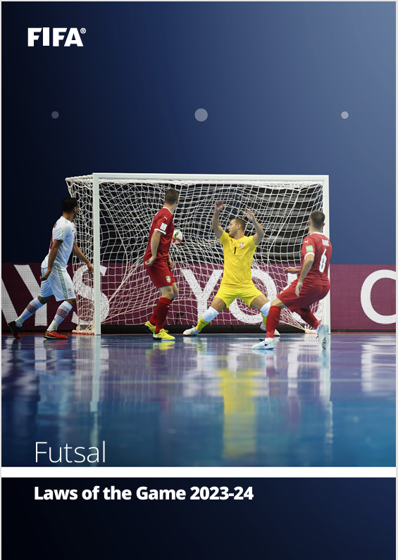

**https://assets.the-afc.com/downloads/referees/FIFA-Futsal-Laws-of-the-Game-2023-24.pdf**

**COSTS**

**Schools will be invoiced by QSF in Term1, 2025**

**$175 per team (1 Day competition)**

**$325 per team (2 Day competition)**

**(covers venue hire, referees, sports trainers, admin fees)**

**REFEREES**

**1 -2 FQ Referees will be supplied for all matches.**

**DISCIPLINE COMMITTEE**

**A discipline committee of 3 teachers will be selected before the start of the season that will decide on all consequences from disciplinary reports. Incident report sheets can be found on the QSF Website and must be completed by both coaches and sent to the committee by the end of the following day after the match**

**RESULTS and TABLES**

**All results for the tournament matches will be recorded on the Referee Match templates and then transferred to a Results sheet in the foyer of the venue.**

**There will be a “10 goal” max winning GD applied to all matches.**

**Results for all matches and updated tables can be found on QSF Website and results will be updated on the website.**

**A Disciplinary Spreadsheet to track “cautions” will be available on the QSF website.**

**TROPHIES, MEDALS and AWARDS**

**QSF Cup champions will receive a Perpetual Premiers trophy and a take-home trophy**

**Runners up and 3rd place getters will receive medals**

**QSF Cup Shield winners will receive the Veto Sports Perpetual trophies. Runners up and 3rd. place getters will receive medals**

**DOCUMENTS**

**All SFL documents can be found on the QSF Website page**

**QSF Website** – queenslandschoolfutsal.com

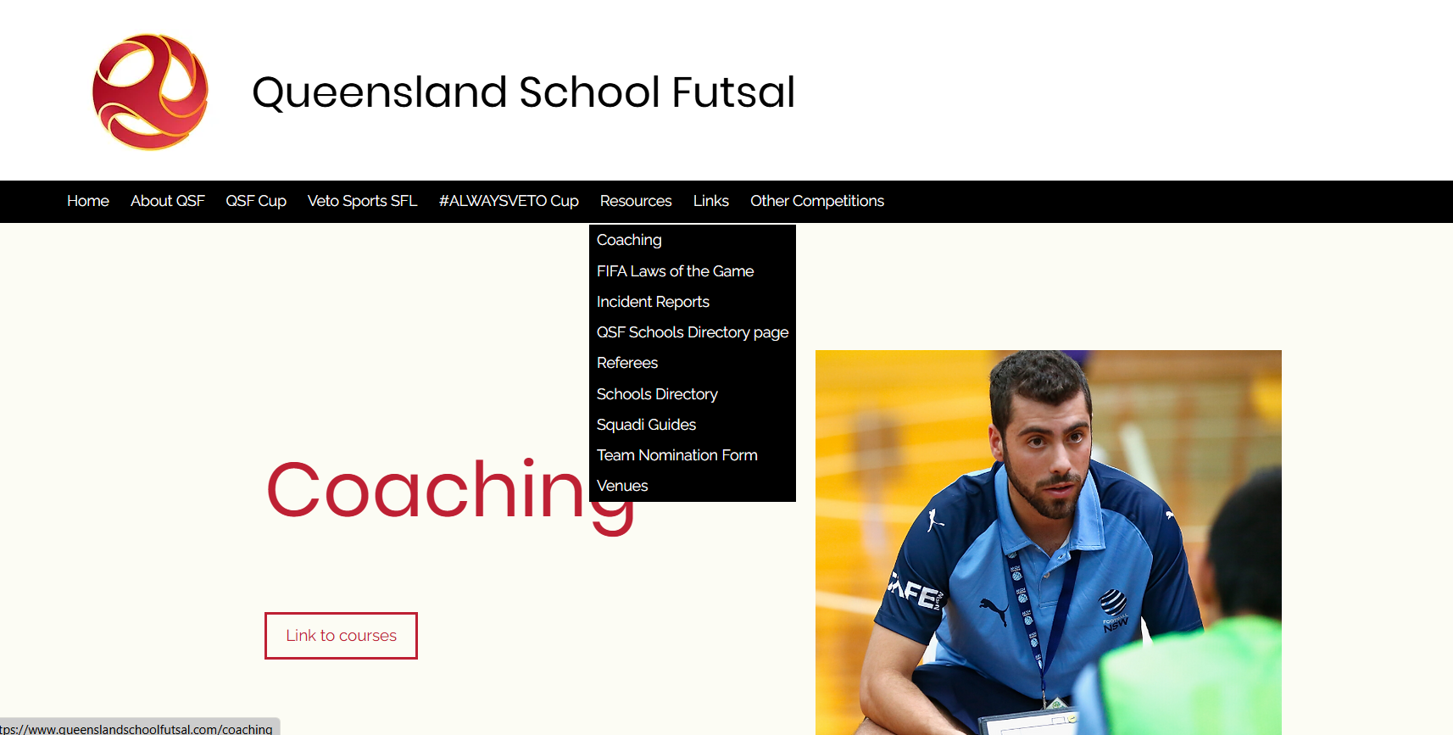

**TEAM LISTS**

**It is requested that schools complete with names, birthdates and principals’ signature and be sent to the convenors as soon as nomination is confirmed (**[**admin@salatimefc.com**](mailto:admin@salatimefc.com)**)**

**SQUAD LISTS**

**It is requested that schools prove “School Squad lists” completed with names, birthdates and photos and sent to the convenors (**[**admin@salatimefc.com**](mailto:admin@salatimefc.com)**)**

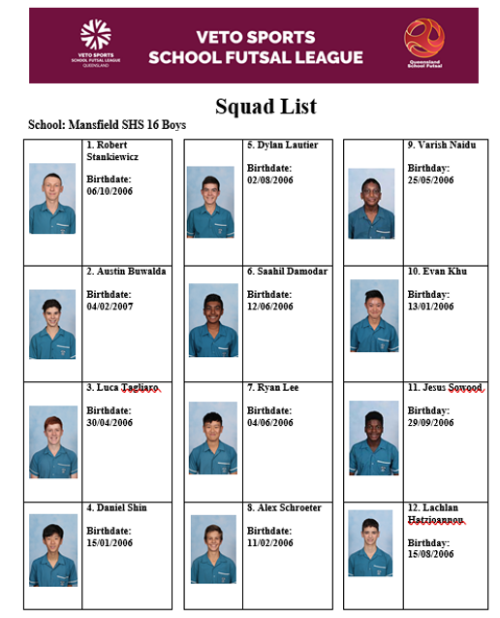

**COMMUNICATION**

**All Coaches and managers are required to join for the QSF WhatsApp group for quick communication purposes before and during the season and will provide updated results, Contact points and news**

**QSF WhatsApp Group**

**STAFF**

**Competition Convenor Referee Coordinator**

**Alan Pradella Fiona Stevenson**

**Match Day Coordinators ([admin@salatimefc.com](mailto:admin@salatimefc.com))**

**Raul Ocan Villegas Gervais Morton**

**SOCIAL MEDIA**

**QSF has a Facebook page and Instagram account for results posts, videos and general advertising purposes. We would like everyone to invite school staff, students, parents and friends to follow the pages.**

**We also encourage coaches and managers to complete the “Player” and “Coach” Profiles and forward them to the QSF Social Media Coordinator – Matt Pickham at mpick68@eq.edu.au**

**SPONSORS**

**ACADEMY ONE FOOTBALL TOURS are the official sponsors of the QSF Cup.**

**Our International Development Tours cater to both boys and girls football squads, providing bespoke travel packages designed in conjunction with team coaches & management.**

**We cover everything from destination selection and football itinerary (including pro-club training, pro-club match tickets, competitive fixtures & ground bookings), flights and accommodation, transport, meal planning, translators and leisure activities.**

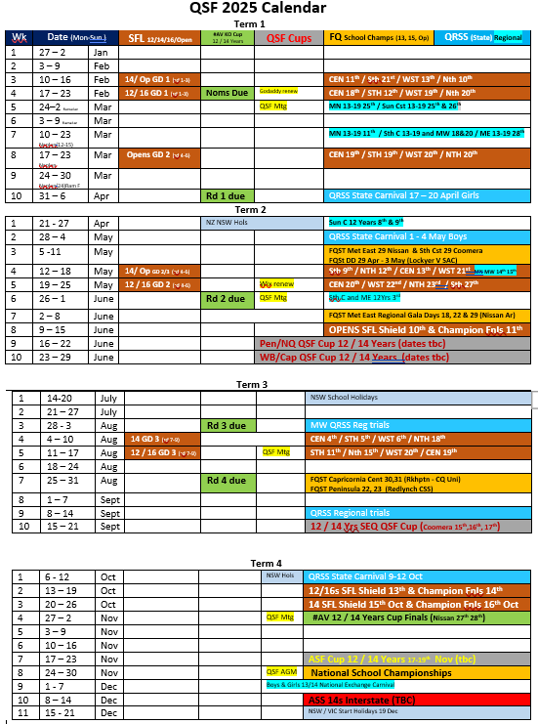

**Australian Futsal Cup: -**

**The “QSF Cup” winning teams will be invited to play in the ASF - Cup competition in late Term 4 against the best NSW, Victorian, ACT teams and South Australian School teams.**

**Overview: - The Australian School Futsal Cup**

This is an Australian secondary school 12 years (primary school) and 14 years, boys and girls Futsal tournament organized be the ASF committee to bring together the best school teams in Australia. The ASF Cup provides the opportunity for all schools to participate and compete against other schools within their district, region and state. All though the ASF Cup is open to all schools in Australia only the top **2 Girls and Boys teams in each age division who have won their respective state qualification titles can enter.**

**Date: - Monday 17th – Wednesday 19th November 2025**

These three days are in the last week of term 4 in the Qld State Secondary school’s calendar which is usually free from assessment or other school commitments. There are also very few clashes with club football/futsal and country regions can arrive on a Sunday play the competition on Monday/Tuesday /Wednesday and then have the Thursday and Friday at the gold coast and or the weekend to possibly go to a Roar match on the Saturday night and then travel home on Saturday or Sunday.

**Venue: - Coomera Indoor Sports and Leisure Centre**

The CISC is a superb world class venue with 8 courts separated with nets, ample off court viewing areas for spectators and multiple canteen facilities

**Age Groups: - 12 & 14 Boys and Girls**

* All students can only participate in one division.
* 14 Age **eligibility** - Students must turn 14 or under in the year of competition
* 12 Age **eligibility** – Students must turn 12 or under in the year of competition and be in Year 6 or below

**Tournament Format: -**

The Queensland School Futsal Cup playoffs will have the following format: -

Once nominations are finalized, the 16 schools will be randomly placed in 4 pools of 4 teams.

On **Day 1** each team in their respective pools will play each other once. At the end of Pool round matches the 8 first and second placed teams from the 4 pools will then be placed into 2 Pools of 4 and compete in the Day 2 **“Cup”** competition. On **Day 2 and Day 3**, the 4 teams in each of the “Cup” Pools will each other once and then at the end of the rounds the first and second placed teams in each of the Cup pools will playoff in crossover Semifinals and the Cup Grand Final. Third and Fourth teams will play consolation finals for positions.

The teams that finish third and fourth in their respective Day 1 Pools will play off for the **“QSF -Shield’** competition and the fifth and sixth positions will play off for the **“QSF -Plate”** on Day 3 in the same format as the Cup competition.