

Convenor’s Welcome

“Queensland School Futsal”- has great pleasure to welcome all school students, teachers, parents, officials and supporters of futsal to the 2024 QSF Cup.

The Queensland School Futsal Cup is part of the Queensland School Futsal program that has laid a strong foundation for the recognition of this exciting sport in the Queensland School Sporting Calendar. The success of the past 14 years and 16 years boys and girls QSF Cups preempts another great tournament this year.

The staging of the carnival would not have been possible without the assistance and sponsorship from Vince Sciacca and Football Queensland, and I would like to publicly acknowledge their support and efforts.

I hope that the experiences that all students will gain while at this tournament will not only benefit them in their ongoing development as players but hope that new everlasting friendships and pleasant memories will form from participation in the competition.

Good luck to all participating teams, coaches and players and remember that it is by playing fair, and respecting your opponents, officials and teammates that not only marks you as a true sportsperson, but demonstrates that kind of personal character needed to successfully enjoy the game we love - "Futsal"

Alan Pradella

Carnival Convenor

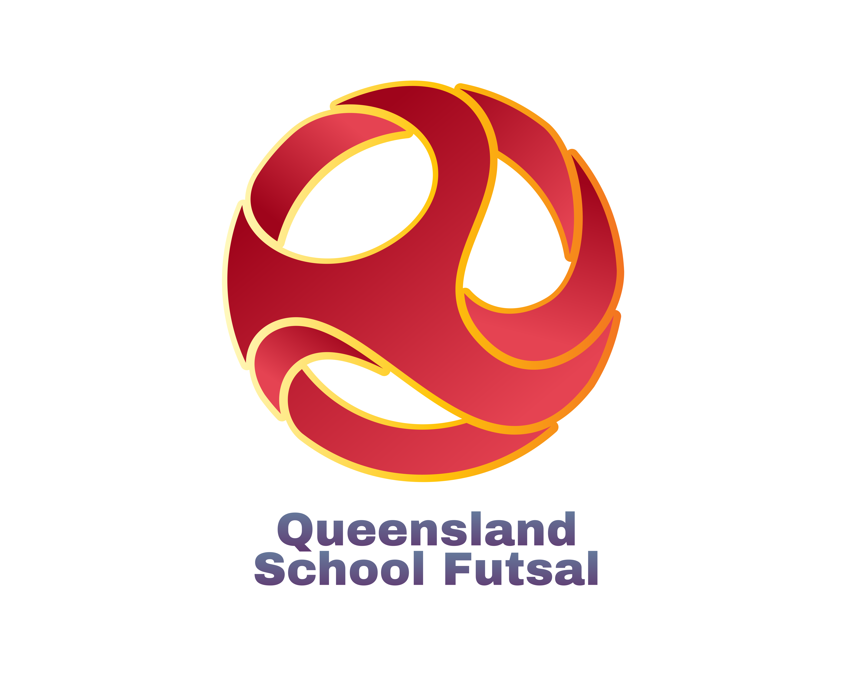

Queensland School Futsal Cup

A 16 Year Secondary Schools Futsal Competition

This is an invitational Queensland School Futsal competition open to all schools in Queensland and provides them with the opportunity to compete against all schools in their District, Region and State.
This is the second year that the competition will play "Full" matches of 40 min matches with full FFA rules. QSF have made the decision that all its competitions will adopt the "proper" format of the game, so this year with the new "Full Match" structure of the 16 Years competition will only invite the first 16 Girls and Boys teams nominating in all 4 divisions so that it will fit a 2-day tournament.

The QSF Cup History

This competition is an initiative by the Queensland School Futsal committee which is a group of secondary school teachers from Queensland sports regions working within the existing QRSS Football committee towards the recognition of “Futsal” as a representative sport within the Queensland Representative School Sport calendar.
Futsal was formally recognized by the Queensland Representative School Sport association in 2021 and state carnivals for 13/14 age groups are now held every year in one of the QRSS 12 sports regions. Students now can attend trials and gain selection to represent their region and be chosen for State teams to play interstate matches in the future. The QRSS program also aims to expand and provide opportunities for student representation in the 15/16 years age group in 2024 who will also be able to gain State and national representation with further age groups targeted in the future.

The Queensland School Futsal history and plan is summarized below:-

2016 - Term 4 (November)
An Invitational Queensland Regional "school" carnival - “13 years QSS Cup” was held at Coomera Indoor sports centre. Regional qualifying tournaments were organized and run with the assistance from various teachers in the three Metropolitan, South Coast, Darling Downs, Wide Bay, Sunshine Coast, Northern, Capricornia and Peninsula Regions in the early part of Term 4, 2016. The best two boys and girls school teams were selected in each region with a follow up Grand Final tournaments on Tuesday 22nd November to crown Redbank Plains SHS and Chancellor SC as the respective boys and girls champion schools’ teams in Queensland.

2017
With the success of the Invitational “schools” carnival in 2016 and with the assistance from the District Sport Secretaries in each region, an invitational State wide “Districts" (or Regional) based carnival was held on Saturday 18th and Sunday 19th November at Carrara Sports centre. Champion Regions - Darling Downs (Boys) and Metropolitan East (girls) There was no QSS Cup in this year.

2018
The 13 yrs QSF Cup continued in Term 1 and 2 with Kings College winning the Boys title and Islamic College Brisbane the girls at Eagles Sports centre at Mansfield.
With support from 7 of the 12 QSS Regional Sports regions, a very successful “Invitational” 13 yrs State Carnival was held at Coomera Indoor Sports centre with South Coast winning the Girls title and Wide Bay were crowned Boys champions.

2019
The 13 yrs QSF Cup continued in Term 1 and 2 with Albany Creek SHS taking the Boys title and Islamic College Brisbane once again being crowned girls champions at Eagles Sports centre at Mansfield. Another very successful “Invitational” 13 yrs State Carnival was held at Coomera Indoor Sports centre with Metropolitan East winning the Girls title and South Coast being crowned Boys champions.

2021
The 13/14 yrs QSF Cup was held at Coomera ISC at the end of Term 2 with 24 boys and 24 girls teams contesting the Cup, Shield and Plate trophies. Kings College won the boys Cup and the Girls title went to Assisi College. Another very successful “Invitational” 13 yrs State Carnival was held at Nissan Arena with Metropolitan East winning the Girls title and South Coast being crowned Boys champions.

2022
A combined 14 and 16 yrs QSF Cup was held at Gold Coast IS & LC at the end of Term 2 with 24 boys and 24 girls’ teams contesting the Cup, Shield and Plate trophies. Kawana Water State College won the 16 boys, 16 Girls and the 14 Boys Cup and the 14 Girls title went to Chancellor State College. The first "Official" State 13 /14 years State Carnival was held at Nissan Arena with Metropolitan West winning the Girls title and Metropolitan East being crowned Boys champions.

2023
The 14- and 16-year QSF Cup resorted back to separate competitions at Coomera ISC at the end of Term 2 and 3 respectively with 24 boys and 24 girls teams contesting the Cup, Shield trophies. Chancellor State College won the 16 boys and Kawana Waters SSC won the 16 Girls. Mabel Park SHS and Trinity College winning the Boys and Girls Shields. The 14 Boys Cup and the 14 Girls title went to The Gap SHS and Chancellor State College and the Shields were won by Ripley Valley SSC and Pimpama SSC.
The second "Official" State 13 /14 years State Carnival was held at Nissan Arena again with Metropolitan East being crowned the Girls and Boys champions.
It has been a slow process of building support first from the “schools”, “districts” and finally the “Regions”, but we believe this process with the ongoing growing support has been finally rewarded with “Futsal” placed on the QRSS State carnival calendar this year with future National carnivals with possible international tours.

Football Queensland (the governing body in Queensland working under instruction from Football Federation Australia) has provided “Full” support for the venture and have been more than willing to provide resources in facilities, coaching and referee courses.

Competition Format and Rules of play

This is a competition for secondary school students who will be 16 years of age or under on December 31, in the year of competition for their respective age divisions and currently enrolled in their competing team school.
Students can only play in “one “division”

The Queensland School Futsal Cup is a “Two Day Competition” where teams need to be successful on the first day of the round robin competition to progress to the “Cup” competition on Day 2. Teams that do not finish first or second in their respective Day 1 pools, may still progress and play for a “Shield” trophy on Day 2.

Competition Format

Day 1 - Playoff stage the 12 teams have been divided into 2 Pools of 6 teams through a
randomized video draw procedure conducted by the QSF Cup committee.
Each team in each pool plays each other once in a round robin competition and
will be ranked by the points system outlined below.

Day 2 – Cup Champions: -

The top 3 teams in each pool from Day 1 will play elimination finals and then
Semifinals.

The teams finishing 2nd and 3rd in the Day 1 Pools will play elimination finals
and the winners will progress to the Semi-finals against the teams that finished
1st in the Day 1 pools. Semi Finals winners will play in the Cup Grand Final.
Semi Final losers will play consolation 3rd and 4th playoffs
Elimination final losers will play, 5th and 6th positional playoffs.

Shield Competition:-

The bottom 3 teams in each pool from Day 1 will play in an identical
competition as the Cup but will play for a the QSF Shield Trophy.
.

DAY 1 and Day 2 - Round robin & Final Matches

Each game shall consist of two periods of 20 minutes with a 5 min half time period. Each team has the option of calling a “One” minute time within the first 18 minutes of each half of the match. The time clock will stop for the time outs.

Points:- 3 Pts - Win
1 Pt - Draw
0 Pts – Loss
3 Pts – Bye or Forfeit

Positions on tables will be allocated by
- overall points
- goal difference
- goals for
- result of round matches
- Number of Red and/or yellow cards
- A penalty shoot out

Red cards - Sent off and automatic suspension for next game plus any punishment meted by the Disputes committee.

Yellow Cards - Two yellow cards in the same game will mean the player is sent from the field and automatic suspension for next game plus any punishment meted by Disputes committee. Two yellow cards in different games over both days will also mean suspension of one match.

DAY 2 – Elimination, Semi and Grand FINALS

Each game shall consist of two periods of 20 minutes, 5 min half time. Each team has the option of calling a “One” minute time out in each half, with the time clock stopped.

If a match is drawn at full time in an Elimination Final, Semi Final or Grand Final there will be two periods of 5 minutes extra time with no intervals or time outs, then FFA rules of penalty kicks to decide the winner.

Rules of Play

- Each game shall consist of two periods of 20 minutes with 5 min half time break.

- Each team has the option to call a “One” minute time out in each half.

- Up to a maximum of 10 players are allowed in each team.

- All 10 players can be used in unlimited interchange.

- All substitutions are to be Rolling substitutions.

- All players must wear shin pads.

- All players are to wear matching numbered shirts and socks (except goalkeepers),
If there is a clash of colors, it is the "HOME" teams (first named on the draw)
responsibility to have an alternate strip or wear bibs. Home teams will run
left to right of the team benches and kick off all matches.
Teams are to swap benches at Halftime.

- Any Team not on court 5 mins after the scheduled kick off time will start with a 2-goal deficit. If there are circumstances out of the team’s control, then points will be awarded to both teams as a draw or rescheduled if possible)

- There will be a “10 Goal Max Goal difference for all results ie., a 16–1 result will be entered as 11-1.

- Normal "FIFA" Futsal rules will apply to all matches.

For Schedule / Results / Tables
There will be an updated scoreboard in the foyer and on "Squadi"



GENERAL INFORMATION

Trophies

Perpetual Trophies are awarded to the winners of each competition. Each player in the "QSF Cup" final competition will be awarded a medallion.

Warm Up and Viewing areas.

Warm-up areas are available outside the venues.
There are only to be players and officials allowed on the court during matches. There is to be no movement behind the goals during matches.

Team Registration

All team managers or coaches are to report to the tournament directors immediately on arrival for registration each day to confirm attendance, check team sheets and receive any updates from the tournament coordinators.

Tournament Coordinators

The tournament directors and scorers will be located at the QSF table in the foyer.

Referees

Football Queensland will provide all referees and try to provide 2 referees per match. If schools can provide “qualified” referees for the tournament, please contact the convenor.

Results Updates

There will be an information screen and updated scoreboards located in the foyer that will be constantly updated with match results and tournament information.

Coomera Indoor Sports Centre
35 Beattie Rd, Coomera 4209

Grandstand (Spectators Viewing area)
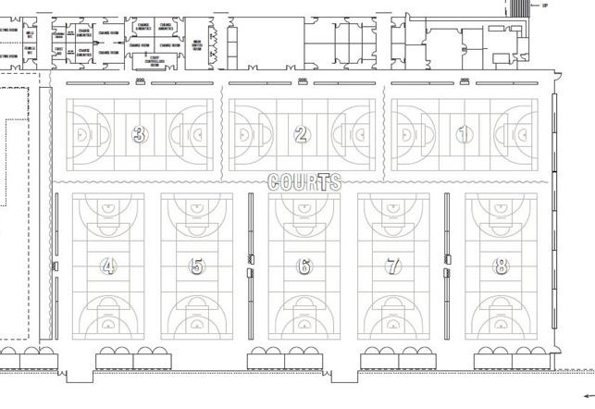



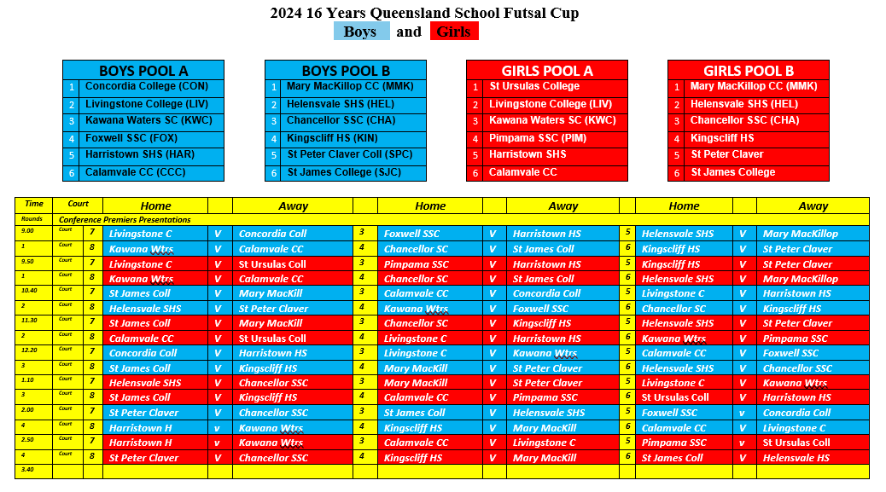
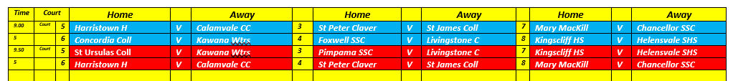
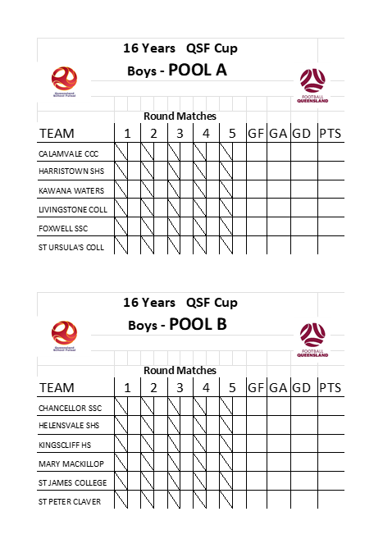

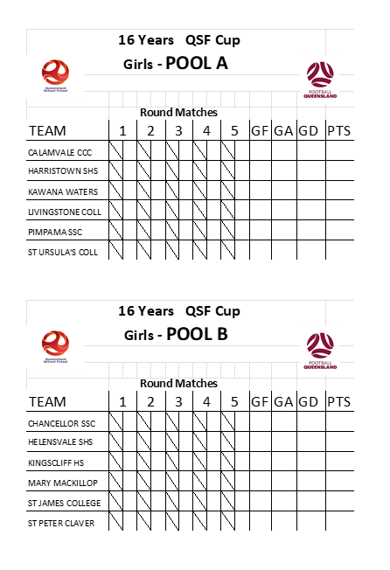
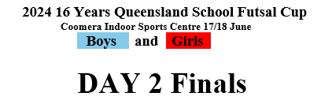

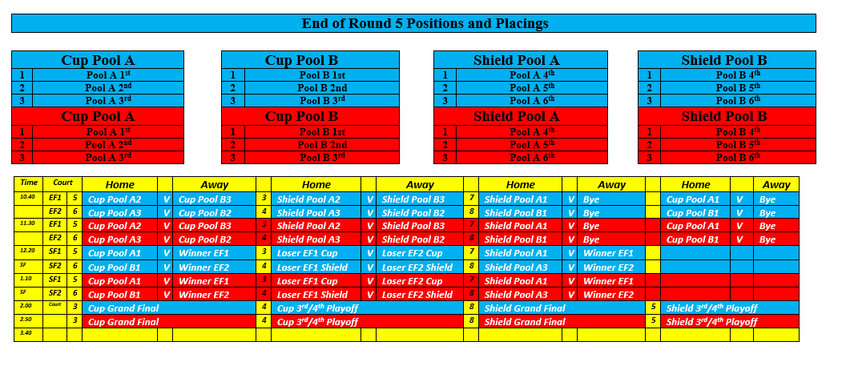
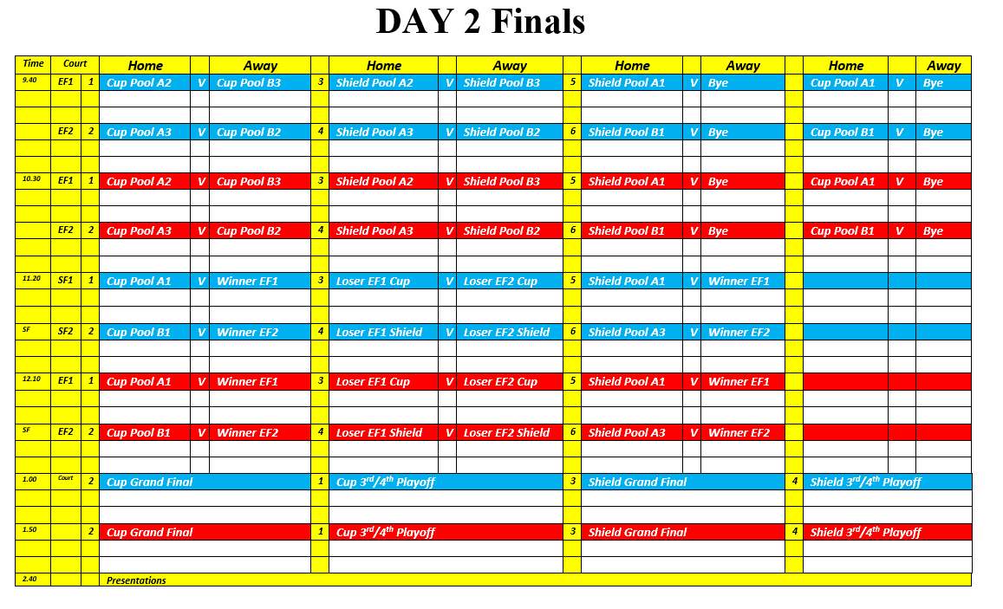

16 Girls - Finals Standings

1 | Cup Champions
2
3
4
5
6

1 | Shield Winners
2
3
4
5
6

16 Boys - Finals Standings

1 | Cup Champions
2
3
4
5
6

1 | Shield Winners
2
3
4
5
6

The QSF cup brings us together to celebrate and enjoy the game of "Futsal".
It provides everyone with the opportunity to compete and most importantly, have fun. All sport, but futsal in particular, provides an environment in which we can meet, socialize and make new friendships with people throughout the state. It is by playing fair, and respecting your opponents, officials and teammates that this becomes possible. Fair play not only marks you as a true sportsperson, but demonstrates that kind of personal character needed to successfully enjoy the game we love - "Futsal"

"Have a great tournament"

`

For Results and Tables

Go to

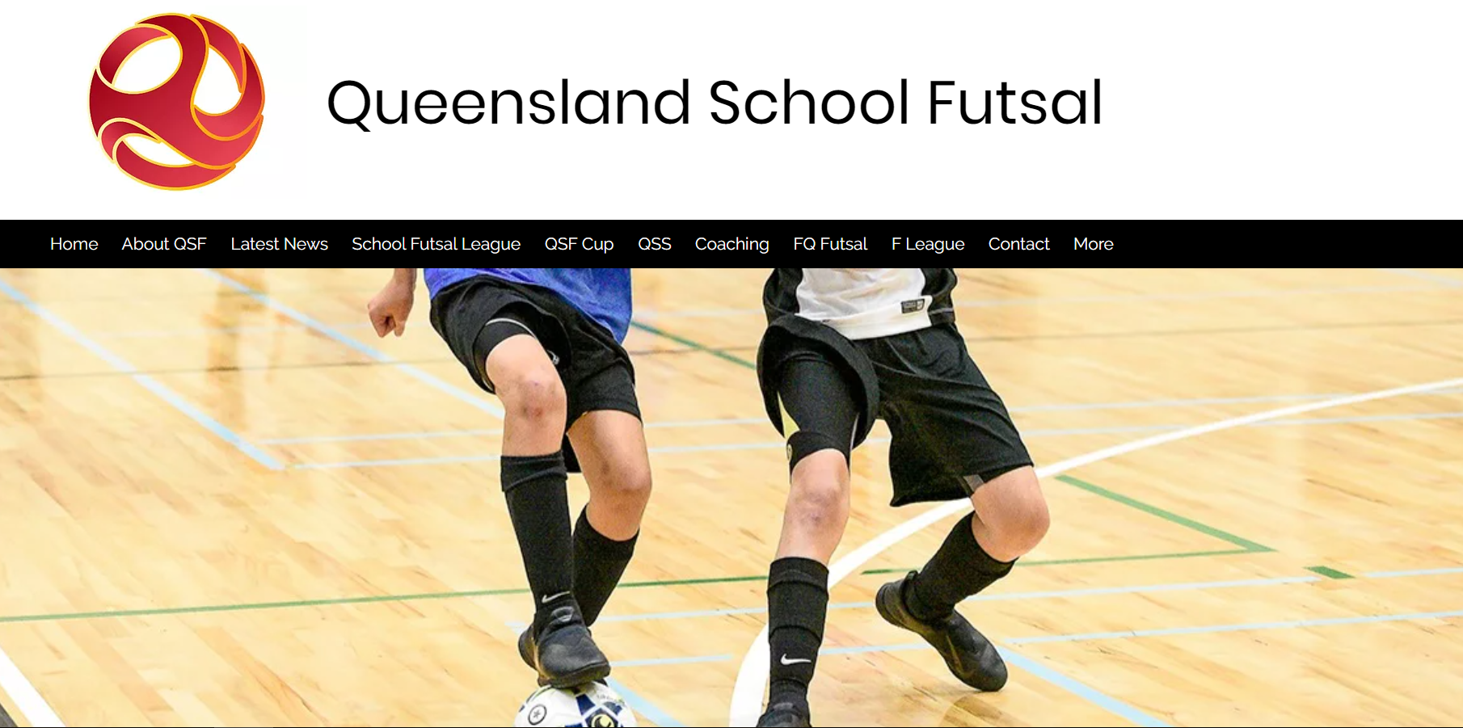

queenslandschoolfutsal.com

