
School |  | Bremer State High School
Address |  | 133-153 Warwick Road, Ipswich, QLD, 4305 | School Finish Time |  |  | 2:50pm
Phone |  | 3810 9333 | Transport |  |  | Bus
Name email Mobile
Coordinator |  | Harry Hanson | Hhans49@eq.edu.au |  |  | 0406628865
Coaches
16 Boys |  | Harry Hanson | Hhans49@eq.edu.au |  |  | 0406628865
16 Girls |  | Giverny Kenman | Gkenm0@eq.edu.au |  |  | 0438274947
14 Boys |  | Harry Hanson | Hhans49@eq.edu.au |  |  | 0406628865
14 Girls |  | Giverny Kenman | Gkenm0@eq.edu.au |  |  | 0439274947
Venue Details
Court 1 |  |  | Court 2
Address |  | Same address as school found in the hall | Same address as school found in the hall
Photo  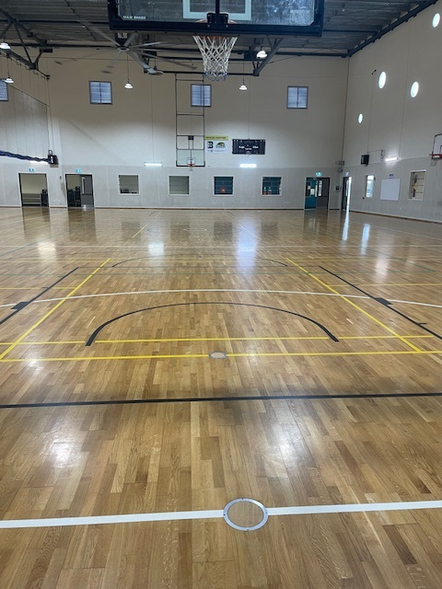 |  |  | Photo  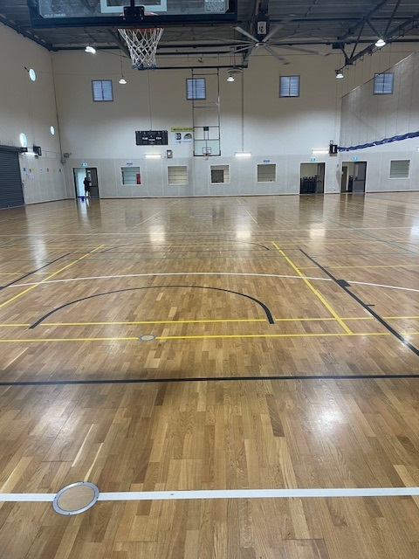
Size | 30m x 15m |  | Size | 30m x 15m
Other Facilities and notes
List
- Accessible toilets
- Digital scoreboards

