
School |  | Mabel Park SHS
Address |  | 62-116 Paradise Road, Slacks Creek | School Finish Time | 2:35pm
Phone |  | 3386 5333 | Transport
Name email Mobile
Coordinator |  | Morgan Roberts | mjrob2@eq.edu.au | 0459439714
Coaches
16 Boys |  | M.Roberts
16 Girls |  | M.Roberts
14 Boys |  | M.Roberts
14 Girls |  | M.Roberts
Venue Details
Court 1
Address |  | Mabel Park SHS
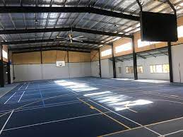
Size | 30m x 15m
Other Facilities and notes

