
Islamic College of Brisbane

Address |  | 45 Acacia Rd, Karawatha, QLD 4117 | School Finish Time |  |  | 3:10 pm
Phone |  | 34525333 | Transport |  |  | School Bus
Coordinator |  | Craig Burchell | cburchell@icb.qld.edu.au |  |  | 0404543462
Coaches |  |  | Email |  |  | Mobile
15/16 Boys |  | Vincent Parry | vparry@icb.qld.edu.au |  |  | 0433674276
15/16 Girls |  | Craig Burchell | cburchell@icb.qld.edu.au |  |  | 0404543462
13/14 Boys |  | Craig Burchell | cburchell@icb.qld.edu.au |  |  | 0404543462
13/14 Girls |  | Shannon Robertson | srobertson@icb.qld.edu.au |  |  | 0431044410
Venue Details
Court 1 |  | ICB MPH (Red Lines) | Court 2 |  | (Karawatha Green Astro- Optional)
Address |  | 45 Acacia Rd, Karawatha, QLD 4117 | 45 Acacia Rd, Karawatha, QLD 4117
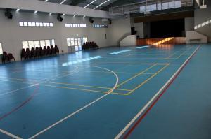 |  |  | 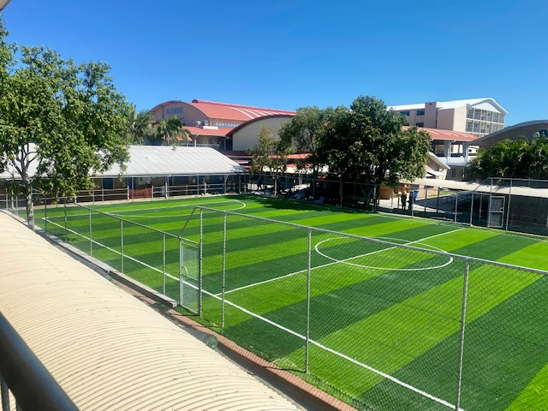
Size | 30m x 15 m |  | Size | 30m x 15 m

