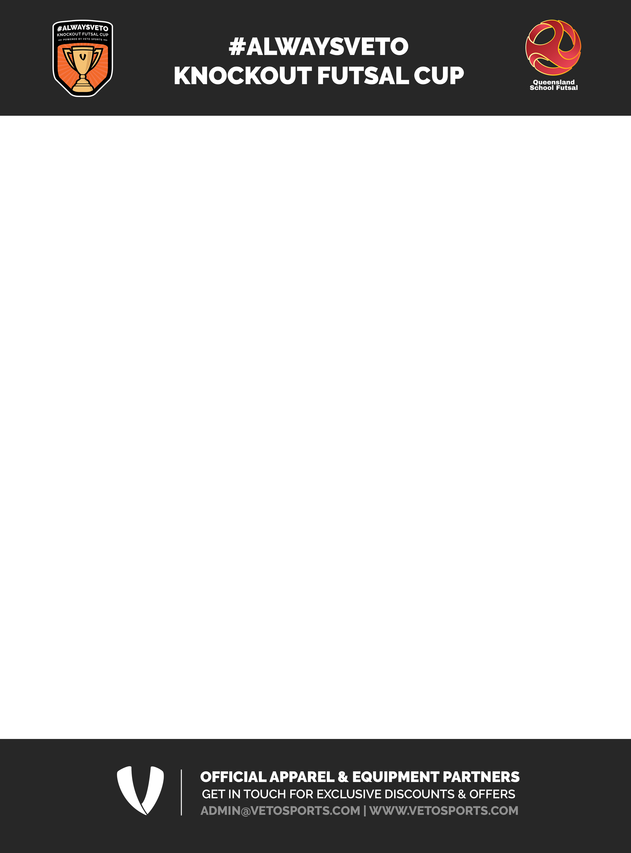
2025 - NOMINATION FORM

School |  |  |  |  |  |  |  |  |  |  | Sport Region |  |  |  | WB/Cap | DD/  SW |  | Pen/Nth | Nth NSW |  |  | Met East |  |  | Met West |  | Sth Cst |  | MN  SC
Address
O
Invoice email
School Futsal Contacts
Email |  |  |  |  |  |  |  |  |  |  |  |  |  | Mobile
Nominated Teams
 |  |  |  |  |  | Tick
12 & under |  | Boys |  |  |  |  |  |  |  | Coach |  |  |  |  |  |  |  |  |  |  | Email
Primary
12 & under |  | Girls |  |  |  |  |  |  |  | Coach |  |  |  |  |  |  |  |  |  |  | Email
Primary
12 & under |  | Boys |  |  |  |  |  |  |  | Coach |  |  |  |  |  |  |  |  |  |  | Email
Secondary
12 & under |  | Girls |  |  |  |  |  |  |  | Coach |  |  |  |  |  |  |  |  |  |  | Email
Secondary
Playing Colors
Jersey |  |  |  |  |  |  | Alt |  |  |  |  |  | Shorts |  |  |  |  |  |  | Socks
Principals Signature
 | I hereby consent for Queensland School Futsal to take photographs of the “ALWAYSVETO Knockout Futsal Cup teams" and use them for the purpose of promoting Queensland School Futsal on its website and social media.

Tick

Return email to: - admin@queenslandschoolfutsal.com
Nominations close Week 10, Term 1, 2025. Schools will be notified of their acceptance into the #ALWAYSVETO Knockout Futsal Cup and provided with information regarding offers with VETO Sports.

